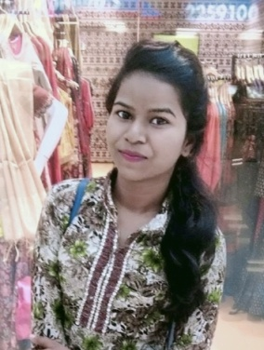**RESUME**

**MADHURI DURGAM**

**Current Address** - New Rajendra Nagar, Raipur, C.G.

**E-Mail ID**  - [madhudurgam777@gmail.com](mailto:madhudurgam777@gmail.com)

**Contact No**. - 6264610045

**CARRIER OBJECTIVE** - Secure a Responsible Opportunity to Fully Utilize My Training and Skills, While Making a Signification to The Success of The Success of The Company.

|  |  |  |  |  |
| --- | --- | --- | --- | --- |
| **Name of Examination** | **Institute** | **Board** | **Year Of Passing** | **Aggregate** |
| 1st | Indrawati Collage Bopallpatnam | Bastar University | 2021 | 50.44% |
| 12th | Govt.H.S.S. Toynar | CGBoard Raipur | 2018 | 50.4% |
| 10th | Govt.H.S.S. Toynar | CG Board Raipur | 2016 | 63.33% |

**PERSONAL SKILLS**

**Computer Proficiency** - Basic of (MS Word, MS Excel, Power Point, Typing)

**On Job Training Attended** – 1. DMLT (6 Month Training, Luvie Collage Raipur )

2. Retail Sales Sector ( 3 Months Training, Kisan Minerals Pvt.Ltd.) DDU-GKY,Ganyari, Bhilai-3, Chhattisgarh.

3. Customer care Executive (3 moth’s training)

**PERSONAL PROFILE**

Father’s Name - Kishtaiya Durgam

Mather’s Name - Rame Durgam

Date of Birth - 06-02-2000

Age - 22 Year’s

Category - SC

Language Knowledge - Hindi, Basic English, Marathi and Chattishgarhi

Hobbies - Read And Watch Cartoon Stories, Panting, Badminton.

DCLATATION - I Here By Declare That The Above Information is True To Best of My Knowledge.

**NAME - MADHURI DURGAM**

**SIGNATURE**