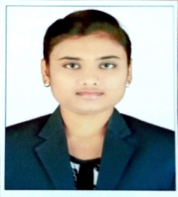**RESUME**

**NIKITA MESHRAM**

**Address: Ward no. 7, Dewki nagar, Gandai, Rajnandgaon (c.g.)**

**Mobile No. :** 9406235416

**Email ID:** nikitameshram2497@gmail.com

**CARRIER OBJECTIVES:-**

To seek a dynamic and challenging career an organization strives for excellence with my knowledge and team effort while making positive contribution to promote the individual opportunity and professional growth.

**ACADEMIC QUALIFICATION:-**

|  |  |  |  |  |
| --- | --- | --- | --- | --- |
| Sr. No. | **Class/ Degree** | **Board/University** | **Year** | **Division /Percentage** |
| 1. | 10th | C.G. Board | 2013 | 72.8% |
| 2. | 12th | C.G. Board | 2015 | 61.6% |
| 3. | B.tech | CSVTU, BHILAI | 2019 | 67.5% |

**Computer SKILL:-**

* **Mailing**
* **English Typing**
* **MS Office (ms word, excel, PowerPoint)**
* **Domestic Data Entry Operator (DDEO)**

**PERSONAL DETAILS:-**

**Father Name: -** : Mahesh meshram

**Date of Birth: -** : 24/06/1997

**Gender: -** : Female

**Marital Status: -** : Unmarried

**Nationality: -** : Indian

**Religion: -** : Buddihest

**Language Knowledge: -** : Hindi & English

**DECLARATION:-**

I hereby declare that the above information is true best of my knowledge.

Date:-10/05/2022

Place:- Raipur NIKITA MESHRAM