**RESUME**

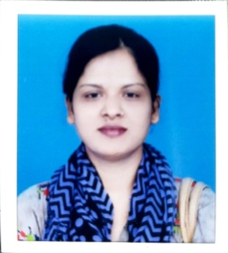**JOOHEE RAWAT**

Mob: 7800525948, 8081087694

Email:jooheerawat@gmail.com

Mo. Qasba, Nizamabad, Azamgarh

Uttar Pradesh- 276206

**OBJECTIVE**

To seek a suitable position in an organization with dynamic environment which offers scope for learning, growth and new challenges where I put my ability to work and prove to be an assets of an organization.

**EDUCATIONAL QUALIFICATION**

* M.A passed from Purvanchal University
* BA Passed from Purvanchal University
* 12th Passed from UP Board
* 10th Passed from UP Board

**TECHNICAL QUALIFICATION**

* ADCA, CCC computer knowledge

**WORK EXPERIENCES**

* Worked in Life Line Hospital & Research Centre 496, Madya, Azamgarh-276001 (U.P.) as an Accounts Executive for 1year.

**PERSONAL INFORMATION**

Date of Birth : 15/08/1996

Father’s Name : Mr. Ram Vriksh Rawat Rawat

Gender : Female

Marital Status : Un-Married

Nationality : Indian

Language : English & Hindi

**DECLARATION**

*I hereby declare the above information is true to the best of my knowledge and belief and faith as a related to my career has been obliterated by me.*

Date: 08-06-2022 Signature Place: Azamgarh (Joohee Rawat)