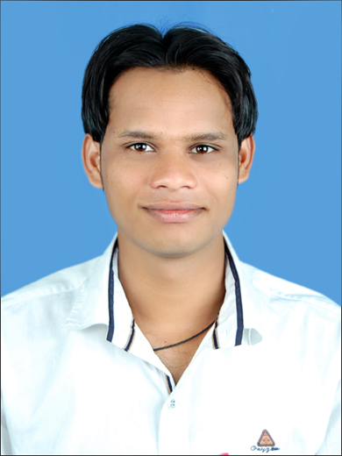
RESUME

GHANSHYAM PATRE
VILLAGE - RICO, POST – PALAUD,
POLICE STATION - MANDIR HASAUD, RAIPUR(C.G.)
CONTACT NO. 9098154130, 7987803353
E_MAIL – ghanshyampatre333@gmail.com

PERSONAL DETAIL

FATHER’S NAME : MR. PAW LAL PATRE
MOTHER’S NAME : MRS. SUMITRA PATRE
DATE OF BIRTH : 06-07-1992
GENDER : MALE
MARITAL STATUS : MARRIED
NATIONLITY : INDIAN
LANGUAGE KNOWS : HINDI, ENGLISH, CHHATTISGARHI
QUALIFICATION DETAILS

S.NO. | CLASS | BOARD/ UNIVERSITY | PER | DIVISION | YEAR
1 | 10TH | C.G. BOARD RAIPUR | 72.23%, | 1ST DIVISION | (2008)
2 | 12TH | C.G. BOARD RAIPUR | 60.00%, | 1ST DIVISION | (2010)
3 | BA III | PT. R.S.U RAIPUR | 60.50%, | 1ST DIVISION | (2014)
4 | MA ENGISH | PT. R.S.U RAIPUR | 38.00%, | 3RD DIVISION | (2016)
5 | M.Sc. IT | CVRU BILASPUR | 72.50% | 1ST DIVISION | (2016)
6 | B. Ed | PT. R.S.U RAIPUR | 65.50% | 1ST DIVISION | (2017-19)

TECHNICAL QUALIFICATION

S.NO. | CLASS | BOARD/ UNIVERSITY | PER | DIVISION | YEAR
1 | DCA | IGNOU DELHI | 71.50% | 1ST DIVISION | (2011-12)
2 | DCA | ASDE RAIPUR | 70.00%, | 1ST DIVISION | (2012)
3 | PGDCA | CVRU BILASPUR | 75.30% | 1ST DIVISION | (2015)
4 | TALLY ERP 9 | TALLY CHAMPS | ISO 9001:2008 CERTIFIED |  | (2015)

EXPERIENCE

- 1 YEAR COMPUTER OPERATOR WORK IN 2010-11 MM FUNCITY GODHI, RAIPUR (C.G.)
- 2 YEAR COMPUTER OPERATOR WORK IN 2015-17 GOVT. MATRI SADAN SR. SEC. SCHOOL MANDIR HASAUD, RAIPUR (C.G.) [PART TIME]
- 4 MONTH VTP TRAINER IN TALLY WORK IN 2017 (CSSDA) HARHEERA EDUCATION SOCIETY MANDIR HASAUD, RAIPUR (C.G.)
- 10 YEAR ACCOUNTANT IN TALLY WORK IN AISECT COMPUTER EDUCATION CENTRE (DR. C.V. RAMAN UNIVERSITY) – MANDIR HASAUD , RAIPUR(C.G.) FROM 2011 TO TILL DATE. (PART TIME)
- 10 YEAR COMPUTER TEACHING WORK IN AISECT COMPUTER EDUCATION CENTRE (DR. C.V. RAMAN UNIVERSITY) – MANDIR HASAUD , RAIPUR(C.G.) FROM 2011 TO TILL DATE.

DECLARATION

I hereby declare that all the information furnished above is true and correct to the best of my Knowledge and belief.
Date –
Place – SIGNATURE
GHANSHYAM PATRE

