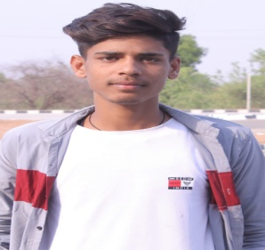RESUME

Najeem khan

**Add** –devbag shrinagar mahoba up

**Mo**.6307485165

**EMAIL** KHANSHEKU82@gmail.com

|  |
| --- |
| OBJECTIVE: |

Willing to work as a player in challenging & creative envirolnment,

Where I can utilize and increase my skills and knowledge.

1. **ACADEMIC QUALIFICATION:**

|  |  |  |
| --- | --- | --- |
| **Examination** | **Board/university** | **%** |
| 10th | Up board | 64% |
| 12th | Up board | 55% |
| B.A 1ST YEAR |  |  |

|  |
| --- |
| EXPERIENCE: |

I am working on computer of selg DDU-GKY in chhatarpur(m.p.) place One year experience in atumobile

|  |
| --- |
| **HOBBIES:** |

* **READING BOOKS**
* **COMPUTER OPERATE**
* **CRICKET**

|  |
| --- |
| **PERSONAL DETAIL.** |

1. NAME : najeem khan
2. Mother’s name : rajiya khatun
3. Father’s name : naseem khan
4. Dob : 10/12/2006

|  |
| --- |
| **Computer sikils:** |

Application, MS word, MS office package, internet surfing & web reasouces. Mponline portai and sssm portal and PAN card