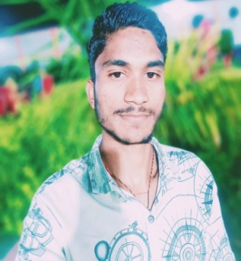**MU. Ovesh**

**Add**- Srinagar mahoba up

**Mo.** 8381978017

OBJECTIVE

Willing to work as a player in challenging &creative evirolment

Where I can utilize and increase my skills and knowledge

ACADEMIC QUALIFICATION;

|  |  |  |
| --- | --- | --- |
| **Examination** | Board /university | Percentage % |
| 10th | Up board | 57% |
| 12 | Up board | 50% |
| running | running | running |

EXPERIENCE :

**HOBBIES:**

**;**

* READING BOOKS
* COMPUTER OPERATE
* CRICKET

PERSONAL DETAIL .

1. name- mu. Ovesh

2.father name - sattar mu.

3.Dob - 15/ 5 /2002

Computer skills:

Application.ms word , ms office package,

Intener surfing &web reasouces. Mponline portal and sssm portal and pan card