RESUME

RESPECTED SIR/MADAM,

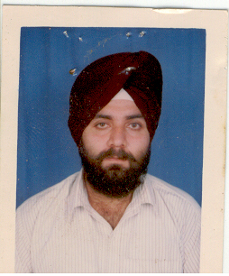
HARJIT SINGH

I PEN DOWN DETAILS OF MY SELF IN BRIEF. HOPE THIS FULFILLED YOUR REQUIREMENT.

NAME HARJIT SINGH

DOB 18 APRIL,1976

QUALIFICATION M.SC IT, GRADUATE,DIPLOMA IN COMPUTERS( PGDCA ), (APTECH),

SALARY 40000 PM

DUTIES ADMIN MANAGER, OPERATIONS,MNAGEMENT,MEETINGS
REPLY COMMUNICATIONS, PREMISES SALE/ PURCHASE,
HANDLE OFFICE/ STAFF, SELDOM TOURS.

SMALL SCALE INDUSTRY CERTIFICATE ON HARDWARE.
SPECIAL I HAVE AN BRILLIANT ACADEMIC CAREER, I
WON MANY PRIZES, I WAS THE EDITOR OF
SCHOOL MAGAZINE,WROTE MANY ARTICLES,
ALWAYS FIRST IN SCHOOL, TAKE PART IN
OTHER ACTIVITIES ALSO.
EXPERIENCE 10 YEARS EXPERIENCE IN COMPUTERS INSTITUTE

ACHIEVEMENTS MEMBER OF ALL INDIA IT ASSOCIATION,
MICROSOFT AWARDED AS TECHNOLOGY SPECIALIST
CERTIFICATE .

I HAVE GOOD PICKING,UNDERSTANDING,CREATIVITY. I ALSO DID JOB IN SGAD COLLEGE, KHADUR SAHIB, DISTRICT TARN TARAN.IF ANY OTHER CLARIFICATION/INFORMATION IS REQUIRED IT WILL BE PLEASURE TO SUPPLY THE SAME ON RECEIPT OF YOUR RESPONSE. IF YOU GIVE ME A CHANCE , I WILL DO MY BEST.

THANKS
YOURS TRULY,
HARJIT SINGH
ADDRESS:=
ANSH COMPUTERS,
B-3/781,KHALSA MARKET, KHALSAPUR ROAD,
DISTRICT TARN TARAN-143401,PUNJAB
INDIA
MOBILE: 9814222255
PHONE 1852-224701
EMAIL ansh_group_tt@yahoo.com
WEBSITE www.AnshGroupOnline.4t.com

