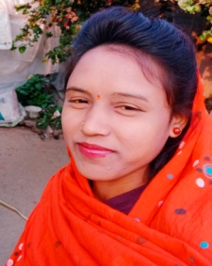RESUME

# KAMINI YADAV

**Mob.:- 8770005149**

**Email :** [**yadawkamini964@gmail.com**](mailto:yadawkamini964@gmail.com)

**Vill :- Nimora.post-Sondhra**

**Dist :- Dharsiwa Raipur (Chhattisgarh)**

**Pin :- 493221**

**ubject :-** Application for the post of **Computer Operator** Respected

sir

With reference to an above subject I have learned that are some vacant posts I would like to apply for the

Same my Bio-data is given below for your kind consideration and personal please,

# Educational Detail :-

|  |  |  |  |  |
| --- | --- | --- | --- | --- |
| **S.No** | **Qualification** | **Board/University** | **Years(Passing)** | **%** |
| 1 | 10TH | C.G. Board Raipur | 2019 | 44.2 |
| 2 | 12TH | C.G. Board Raipur | 2021 | 49.8 |
| 3 | DCA | Dr. CV Raman University (C.G) | 2022 |  |

**Personal Details :-**

Name - **KAMINI YADAV**

Father’s Name - **Mr. RAJ KUMAR YADAV**

Date of Birth - 26/04/1999

Sex - Female

Marital status - Unmarried Nationality - Indian

Religion - Hindu

Languages - Hindi & English

# DECLARATION :-

I do hare by declare that al information in Repect of my Bio-Data give this correct to the best of my knowledge and belief.

# Place :- ………………

**Date :- ………………. KAMINI YADAV**