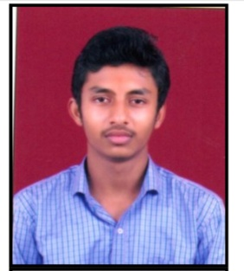**Imanshu yadav**

E-mail : [imanshuyadav0@gmail.com](mailto:imanshuyadav0@gmail.com)

Mobile No: 7470456487

**Personal Profile:**

Name : Imanshu Yadav

Father’s Name : Tuman Lal Yadav

Material Status : Unmarried

Nationality : Indian

Present Address : Gali no.1 Near Gurudwara, Shayam Nagar, Raipur(C.G.)(492001)

Gender : Male

Date of Birth : 21-04-2004

**Objective :**

To pursue a highly challenging career in the IT industry and work closely with a team of highly experienced professionals so as to enable myself to grow along with the firm .

**Academic Chronicle:**

|  |  |  |  |
| --- | --- | --- | --- |
| **Degree** | **University** | **Period of course** | **Obtained Grade** |
| 10th | C.G. Board | 2018-2019 | A |
| 11th | C.G. Board | 2019-2020 | A |
| 12th | C.G. Board | 2020-2021 | A |
| DCA(Appear) | PRSU | 2021-2022 |  |
| B.A. 1st Year( Appear) | PRSU | 2022-2023 |  |

**Other skills:**

1. Ms Office (MS Word , MS Excel, MS Power point).
2. English Typing.
3. Hindi Typing.
4. Using HTML .
5. Web Developer (Appear).

**Declaration :**

I hereby declare that all the above information furnished about me is true to the best of my knowledge and belief.