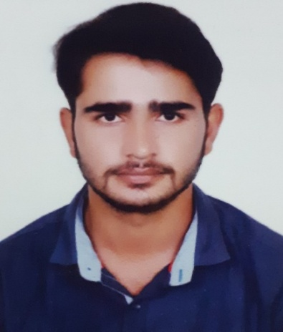

SHUBHAM MEENA
Contact No. : 8461876467
Email ID: shubhamsmeena007@gmail.com
https://www.linkedin.com/in/shubhameena007

CAREER OBJECTIVE

To be a part of a progressive organization where my knowledge & skills can contribute to the company’s goals and achievements and aid to my personal and professional growth.

EDUCATION QUALIFICATION

Degree/ Certificate | Institute/ School | Board / University | Year of Passing | Result
MBA (finance & Banking) | Institute of Professional Education and Research,(IPER) Bhopal, M.P | Barkatullah University, Bhopal | 2020-22 | Pursuing
B.COM (accounting) | Sect college of professional educational, Bhopal, M.P | Barkatullah University, Bhopal | 2015-18 | 63%
HSSCE (commerce) | Rana pratap higher secondary school, Bhopal, M.P | MPBSE Bhopal | 2013-15 | 64%
SSC | Maharishi center for educational excellence, Bhopal, M.P | C.B.S.E New Delhi | 2012-13 | 5.6
PGDCA | Makhanlal Chaturvedi national university, Bhopal, MP | Makhanlal university, Bhopal | 2018-2019 | 70.50%

SKILLS & PROFICIENCY

- Computer & IT : MS Office, G-Suite, email ,digital marketing, internet access
- Finance & banking :financial analysis , communication, accounting, corporate finance, analytical skill, management, banking operations .

ONLINE CERTIFICATIONS

- Name : Financial Markets by Yale University.
Source/Agency : Coursera
Details : Introduction to risk management and behavioral finance principles to understand the real-world functioning of securities, insurance, and banking industries.

2. Name : The Fundamental of Digital Marketing.
Source/Agency : Google Digital Garage
Details : Illustrating alternative marketing management strategies,
Introducing the importance of the digital marketing and learn about how to manage
online business Marketing.

INTERNSHIP

- Company : Gps Gatwaye India Pvt.Ltd
- Duration : 2 month (15 June 2021 to 15 August 2021)
- Job roles & Responsibilities : 1. To develop and implement different types of digital marketing strategies/animation techniques 2. To assist in marketing and advertising promotional activities (e.g. Social media, direct mail and web LinkedIn) 3. To collaborate with digital marketing team.

ACADEMIC PROJECTS

- Title : Project Management Lifecycle Report (Multilevel Parking)
Objective : To know and create an easy to follow framework, coming up with the new ideas, defining goals, planning for execution and then guiding it to completion of project.

- Title : Do Organizations have a Formal Knowledge Management System?
Objective : To know and asses that how different tools and techniques of knowledge management system are used by different kind of organizations and its impact on organizations performance.

EXTRA CURRICULAR ACTIVITIES

MBA
- Participated in panel discussion activity 2020.

HOBBIES & INTERESTS

- Playing cricket.
- Reading.
- Running.

PERSONAL DETAILS
- Father’s Name : Mr. Pravat Singh Meena
- Date of Birth : 05-February-1998
- Permanent Address : House no. 14/2 New Jail Road Badwai Bhopal, Madhya Pradesh, 462038

DECLARATION

I hereby declare that the above Information is true to the best of my knowledge.

Place: Bhopal
Date: (SHUBHAM MEENA)

