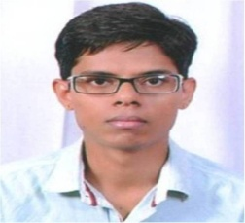CURRICULUM VITAE

MAHENDRA SINGH SOLANKI

# CAREER OBJECTIVE :-

* To be a part of reputed organization which provide a steady career growth along with Job – satisfaction & challenge and to give value contribution in the success of the Organization.

## EXPERIENCE :-

* **Company :-** Medical and Health Department Information Assistant **(Contract Basis)**

## Location :- Takhatgarh, Pali

## Designation :- Information Assistant

**Time Period :-** From 1st Nov 2014 to Till Date

**Software Use :-**

* Different Software used in Hospital as suggested by Govt.
* MS Office (Word, Excel )

**Job Profile :-**

* Data Entry in Different Software.
* Handling different MIS
* Other office related work.

# EDUCATIONAL QUALIFICATION :-

* BCA from MDS University Ajmer in 2012
* Intermediate from Board of Secondary Education Rajasthan in 2009
* Matriculation from Board of Secondary Education Rajasthan in 2007

## PERSONAL DETAILS :-

Father’s Name : Sh. Naval Singh

Date of Birth : 18th Mar., 1989

Address : Post Office Gali, Takhatgarh

Teh :Sumerpur , Dist.-Pali,

Rajasthan -306912

Contact No. : 9783312329

E-mail : mssolanki789@gmail.com

Language Known : Hindi & English



**Date : 19.09.2022**

**Place : Takhatgarh**

**(MAHENDRA SINGH SOLANKI)**