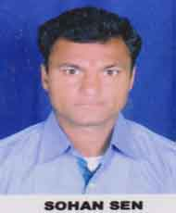Resume

**Ganesh Parmar**

Address :- Gram Bhoura Dist Sehore

Contect:- 7067053591

**Objective:-**

I am a dedicated person who wants to use her skills and education to help students achieve using both traditional and modern approaches.

Objective:-

|  |  |  |  |  |
| --- | --- | --- | --- | --- |
| **QUALIFICATION** | **SUBJECT** | **BOARD/UNI.** | **YEAR** | **RESULT** |
| 10th | ALL | MP Board Bhopal | 2008 | Pass |
| 12th | ARTS | MP Board Bhopal | 2011 | Pass |

**Experience:-** One year Experience in Computer operator in AISECT PMKK Sehore.

**PERSONAL PROFILE:-**

Father”s Name Mr. Bhagwan Singh

Mothers Mrs.Ladkuwar Bai

DOB 29-May-2002

Gender Male

Language Hindi

**Declaration:-**

I here by declare that the above information given is true to the best of my knowledge.

**Place:- Sehore**