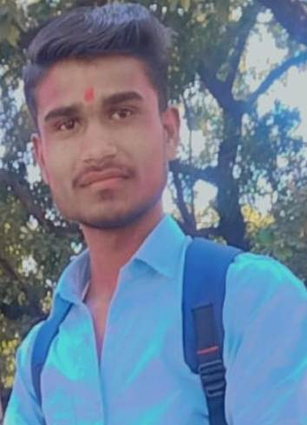**CV**

VIJAY VISHWAKARMA

**7024193483**

E-mail :- [vijayvishwakarma6264118989@gmail.com](mailto:vijayvishwakarma6264118989@gmail.com)

ADD :- Villege,post padariya

Vijay vishwakarma

Dist :- Chhatarpur(M.P) Pin :-471408

Objective :- Iwant to excel in this field with hard word, perseverance and

Dedication.

**Education Qualification:**

|  |  |  |  |
| --- | --- | --- | --- |
| Course | School/university | Passing years | Persentage% |
| 10th | Govt. School padariya | 2019-20 | 57.7% |
| 12th | Govt. School padariya | 2021-22 | 52.3% |
| B.A Running | Mcbu college | 2022-23 | Running |
| DCA Running | Rntg university | 2022-23 | Running |

**Personal profile:-**

|  |  |
| --- | --- |
| **Father’s Name:** Mr. Raju vishwakarma | **DOB:** 20/01/1998 |
| **Mother’s Name:**  Smt. Leela vishwakarma | **Nationality:** Indian |
| **Gender:** Male | **Language known:** Hindi, English |
| **Marital Status:** Unmarried | **Contact no.7024193483** |

My Hobby :-

1. My dream become SI officer
2. Student’s teaching in coaching center
3. Word excel power point
4. Dca Pursuing in RNTU university Bhopal (M.P.)

PLACE –CHHATARPUR VIJAY VISHWAKARMA

DATE -