resume

Student Name –Krashna kushwaha

Father’s Name Mr.Kandu kushwaha

Disst. Chhatarpur M. P.

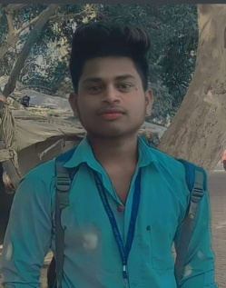Tahshil – Chhatarpur M.P.

Pin Code 471001

Cont.Number 7024651442,7000015839

E-mail [Id.Krashnak205@gmail.com](mailto:Id.Krashnak205@gmail.com)

Obejective .I want to excel in thisfilde with hard word ,perveserance and Dedication

Education Qualification

Qu Parasnile alification

|  |  |  |  |
| --- | --- | --- | --- |
| Course | School University | Passing Year | Parsentage |
| 10th | Govt.Hss Padariya | 2018-19 | 75% |
| 12th | Govt. Hss Padariya | 2019-20 | 71% |
| B.A Fist Year | M.C.B.U. Chhatarpur | 2020-21 | 60% |
| B.A Second Year | M.C.B.U. Chhatarpur | 2021-22 | Runing |

DCA RNT Chhatarpur 2022-23 Runing

|  |
| --- |
| Name Krashna kushwaha |
| Father Name Mr.Kandu kushwah |
| Adress.Gram Post Padariya distt. Chhatarpur madhyapradesh India |
| Mobaile Number- 7024651442,7000015839 |
|  |