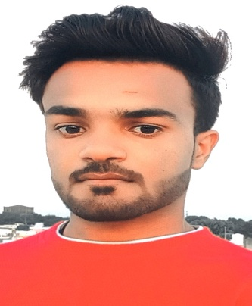**CV**

Beerendra Yadav

**9685975277**

E-mail :- [beenendray101@gmail.com](mailto:beenendray101@gmail.com)

ADD :- Villege,shivrajpur post, chandnagar

Beerendra Yadav

Dist :- Chhatarpur(M.P) Pin :-471408

Objective :- Iwant to excel in this field with hard word, perseverance and

Dedication.

**Education Qualification:**

|  |  |  |  |
| --- | --- | --- | --- |
| Course | School/university | Passing years | Persentage% |
| 10th | Govt. School chandnagar | 2018-19 | 49.4% |
| 12th | Govt. School chandnagar | 2020-21 | 47.4% |
| B.S.C Running | Shri Krishna university college | 2022-23 | Running |

**Personal profile:-**

|  |  |
| --- | --- |
| **Father’s Name:** Mr. Ramcharan Yadav | **DOB:** 25/01/ 2003 |
| **Mother’s Name:**  Smt. Leela Yadav | **Nationality:** Indian |
|  | **Language known:** Hindi, English |
| **Marital Status:** Unmarried | **Contact no. 9685975277** |

My Hobby :-

1. My dream become SI officer
2. Student’s teaching in coaching center
3. Word excel power point
4. Dca Pursuing in RNTU university Bhopal (M.P.)

PLACE –CHHATARPUR Beerendra yadav

DATE -