resume

Student Name –sanjay mishra

Father’s Name Mr.late sarju prasad mishra

addres-behind the narmada hospital infront of bradha aashram kishore sagar ke pass chhatarpur m.p.

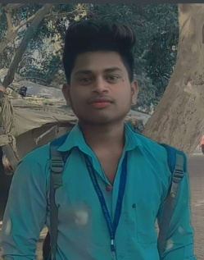Pin Code 471001

Cont.Number -7389346932

E-mai

Obejective .I want to excel in thisfilde with hard word ,perveserance and Dedication

Education Qualification

Qu Parasnile alification

|  |  |  |  |
| --- | --- | --- | --- |
| Course | School University | Passing Year | Parsentage |
| 10th | CBSE BOARD | 2013-14 | 8.4cgpa |
| 12th | M.P. BOARD | 2015-16 | 61% |
| b.pharma | RGPV bhopal | pursuing | pursuing |
| dca | makhanlal univercity | pursuing | pursuing |

|  |
| --- |
| Name-Sanjay mishra |
| Father Name Mr.late sarju prasad mishra |
| Adress.Gram –behind the narmada hospital near kishoe sagar talab chhatarpur m.p. |
| Mobaile Numbe-7389346932 |
|  |