**Rojgar Mantra Date 27-01-2023**

1. Save and next not working => Done

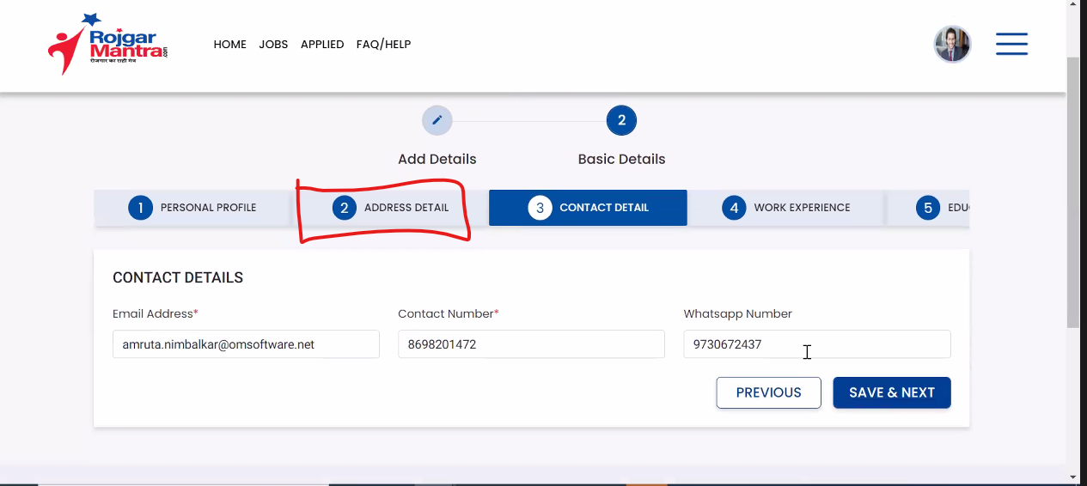

1. Payment Gateway is not active in candidate => API not working

<https://rmn-api.rojgarmantra.com:8088/api/v2/paymentGateway/membershipCost?PlanId=21>

{"timestamp":"2023-02-01T08:39:39.120+00:00","status":404,"error":"Not Found","path":"/api/v2/paymentGateway/membershipCost"}

1. Home page static

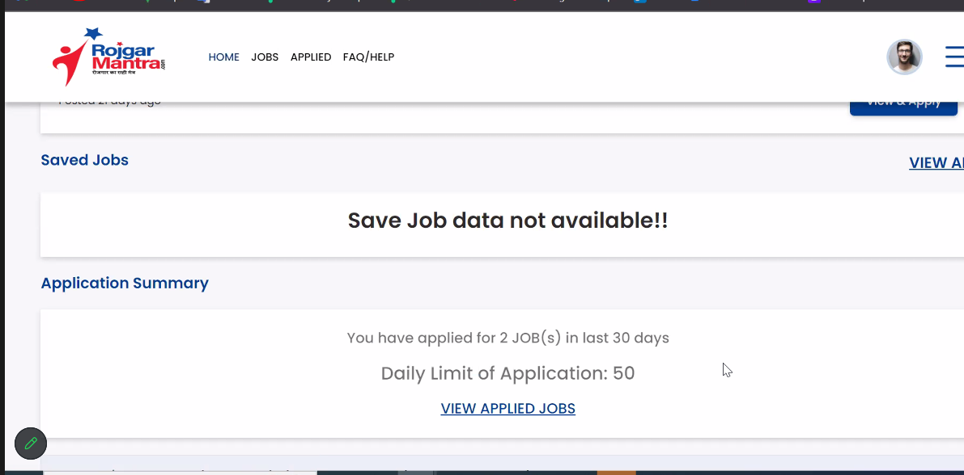

1. Search by State and District

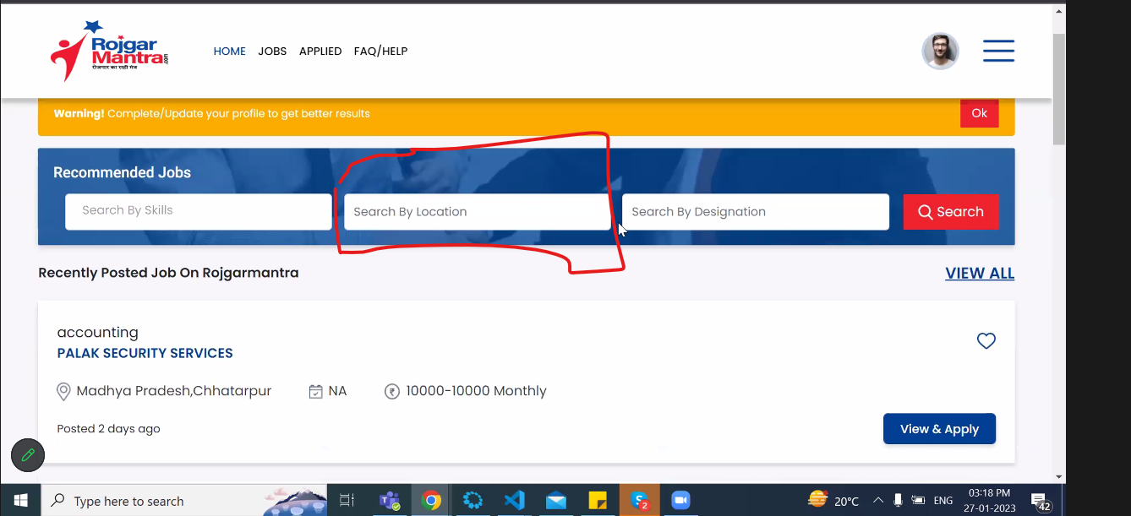

1. Pop up message/ warning message to validate the OTP
   1. NEW OTP will go ok click of OK
2. Point no 8
   1. Make mandate to fill
3. Resume Booster (employer)
   1. Work on the search candidate
   2. Should be seen on the top
   3. Search should be with designation
   4. Search by education
4. 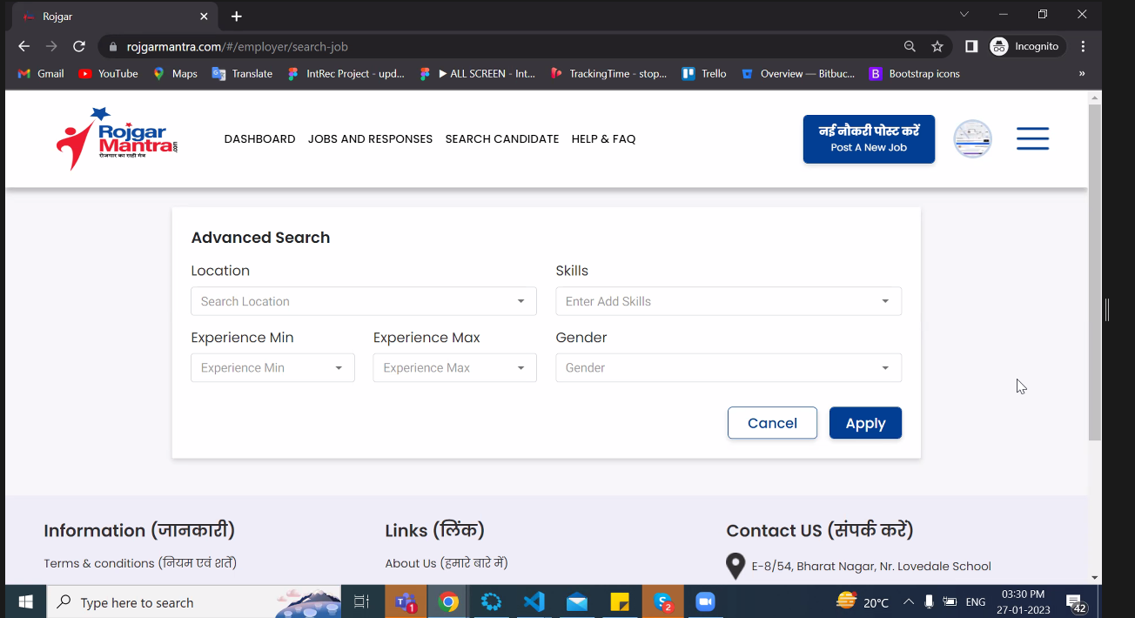
5. Candidate should see the job related to the skills
6. Show filter which is hidden we need to activate it
7. Before applying the candidate should complete the profile page all forms.
8. Create job alert is not working – need to check

**Employer**

1. Team Member
   1. The team member is not visible
   2. The mobile number already exist in the database need to be cleared
   3. Remove eye
   4. Profile updating not working
   5. When we favorite one candidate other team member should also see the favorite marked candidate

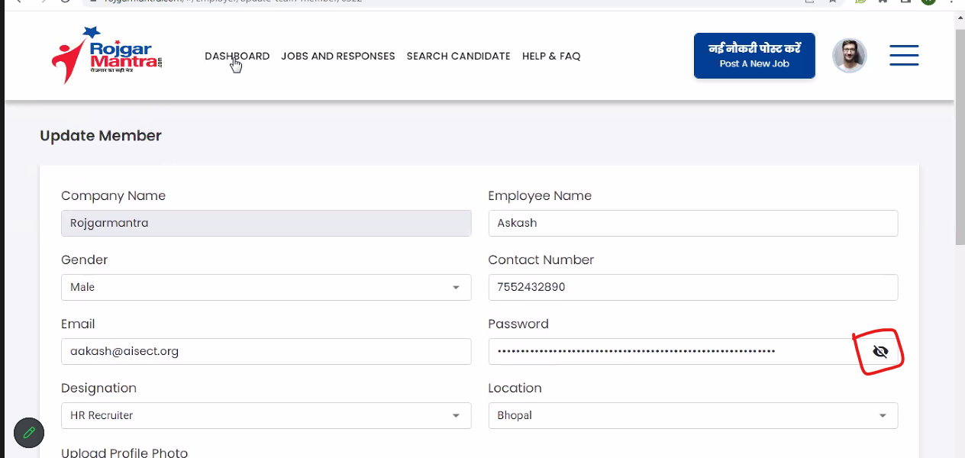

1. In job
   1. Need edit option
   2. Repost

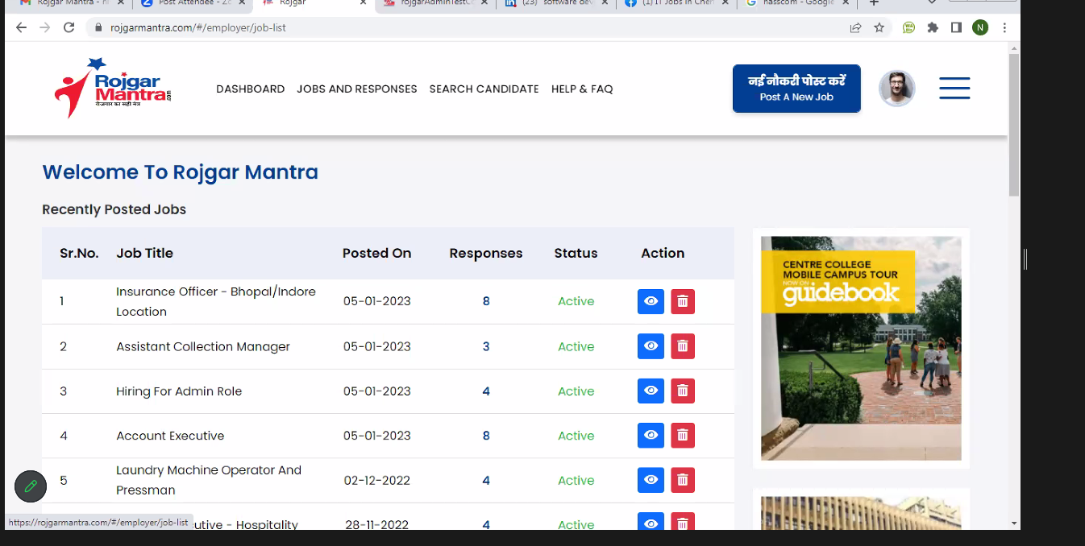

1. Admin decide whether the login should be multiple or single (Multiple Login)
   1. Old account logout the new will be logged in (1 user- 1device – 1 time)
2. Plan expire should shoot a mail
3. Job post response – mail should receive about the candidates applying to job
4. Company profile should be made mandate before posting the job
5. Other profile details are getting updated in other profile page in both candidate and employer both.

ADMIN

1. Manager users
   1. Post all jobs – at once all job should be posted
2. Should be able to delete

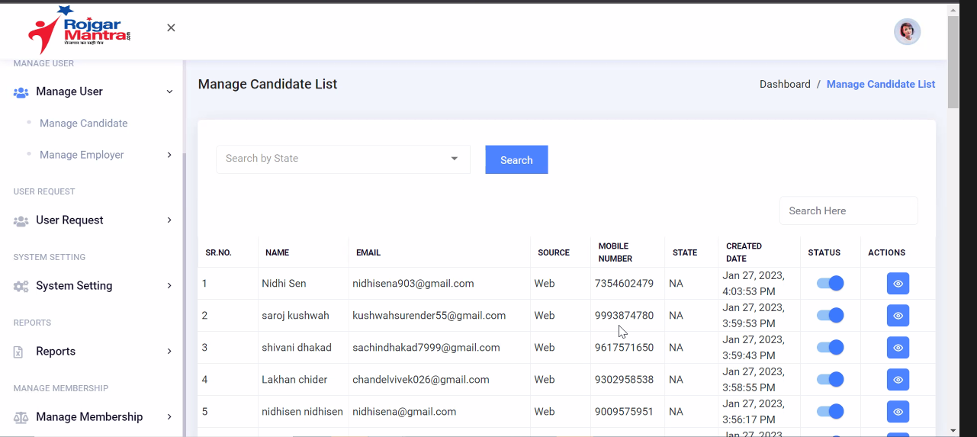

1. Similar to blog : Manage news should be shown

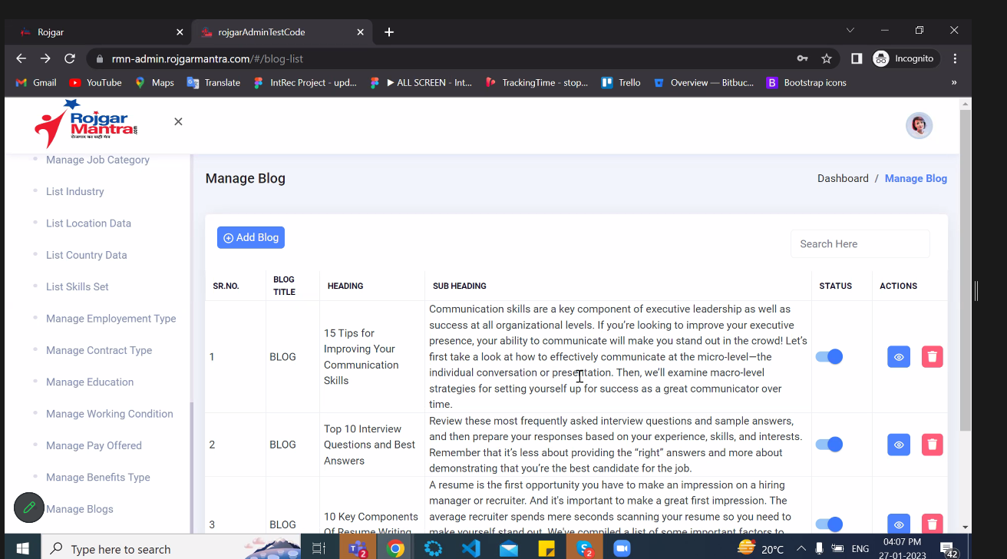

1. On the homepage show the latest news and link to news
2. Bulk mail, sms, WhatsApp
   1. For candidate and employer
   2. Whose profile is incomplete should be seen and they can be selected and send message at once
   3. All the employer and the candidate list should be export in excel format
3. Search by district

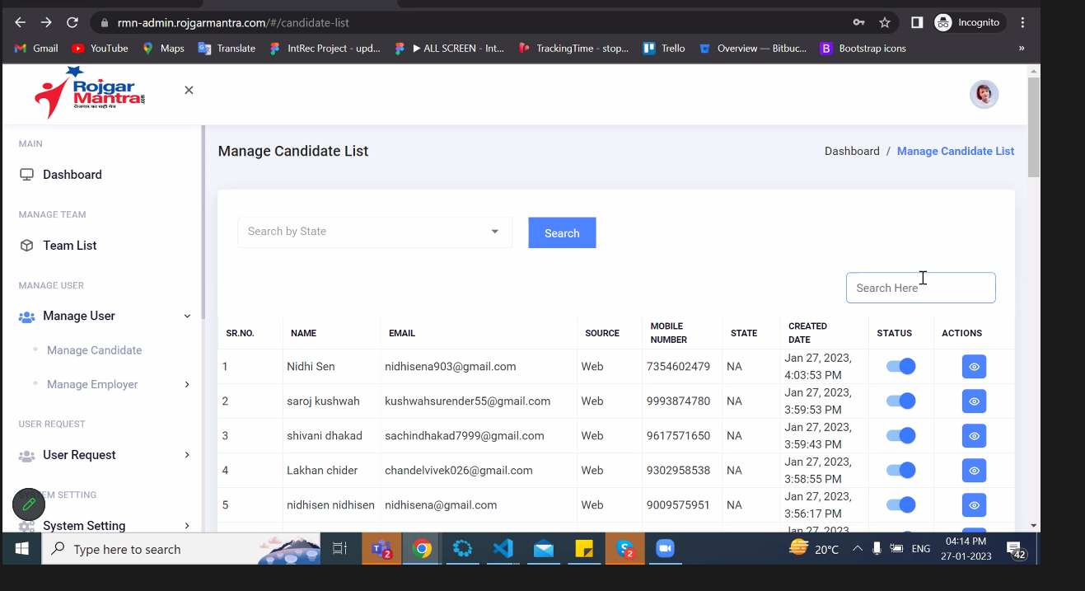

1. In admin: Import
   1. Should be able to import the employer and the candidates in bulk to the system