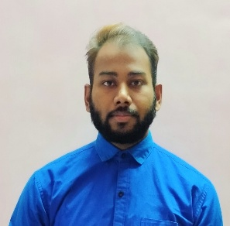

**Rajat Mehra**

**Email Id :- mehrarajat868@gmail.com**

**Contact No.:9617362329, 8109768871**

**Address:C-41/19 Rishi Nagar extension Ujjain (MP)**

**CAREER OBJECTIVE**

To work in a professional environment so as to enhance my skills and work to my full potential for the objective of the organisation

**WORK EXPERIENCE / (EDUCATION *if fresher)***

* **Fresher**

**TECHNICAL SKILLS**

* **Knowledge of computer**
* **Tally ERP 9 with (GST)**
* **Advanced Excel**

**EDUCATION *(if experienced)***

|  |  |  |  |  |
| --- | --- | --- | --- | --- |
| **Course** | **Institute / School** | **University / Board** | **Marks** | **Year** |
| **MBA (Finance & Marketing)** | **Mahakal institute of management** | **Vikram University** | **64%** | **2022** |
| **B.com (H)** | **Vagdevi bhawan** | **Vikram University** | **5.79**  **CGPA** | **2019** |
| **12th** | **Kalidas Montessori school** | **MP Board** | **56.4%** | **2016** |
| **10th** | **Kalidas Montessori School** | **MP Board** | **54.3%** | **2014** |

**WORKSHOP / SEMINAR**

* **DYS webinar certificate**
* **Kona kona siksha (kotak Mahindra) NISM certificate**

**PERSONAL DETAILS**

* **Father’s Name -** Late. Suresh Mehra
* **Mother’s Name -** Chandrakala Mehra
* **Date of birth -** 21/01/1998
* **Language -** Hindi & English
* **Marital status -** unmarried
* **Religion -**  Hindu

**Date:** Yours Sincerely

**Place: ( Rajat Mehra )**