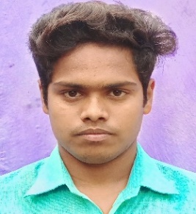**RESUME**

**Name- Nandkishor Yadav Mob.-639481305**

**Add. – Vill- Molnapur, Post- Ambarpur, Azamgarh, 223227**

**Email - 7863nandkishoryadav@gami**

***OBJECTIVE***

* To work with an organization where can learn new skills and increase my abilities for the organizational goals as well as myself.

QUALIFICATION

* Pursuing B.Sc. 2nd year from msdsu azamgarh
* Intermediate U.P. Board in 2019
* High school U.P. Board in 2021

SKILLS

sS

* MS word
* MS excel
* Typing

HOBBIES

* Reading

PERSONAL PROFILE

Date of birth: 10/11/2003

Father’s Name: Mr. Lalbahadur Yadav

Mother Name: Mrs. Kiran

Language known: English & Hindi

Nationality: Indian

Nandkishor yadav