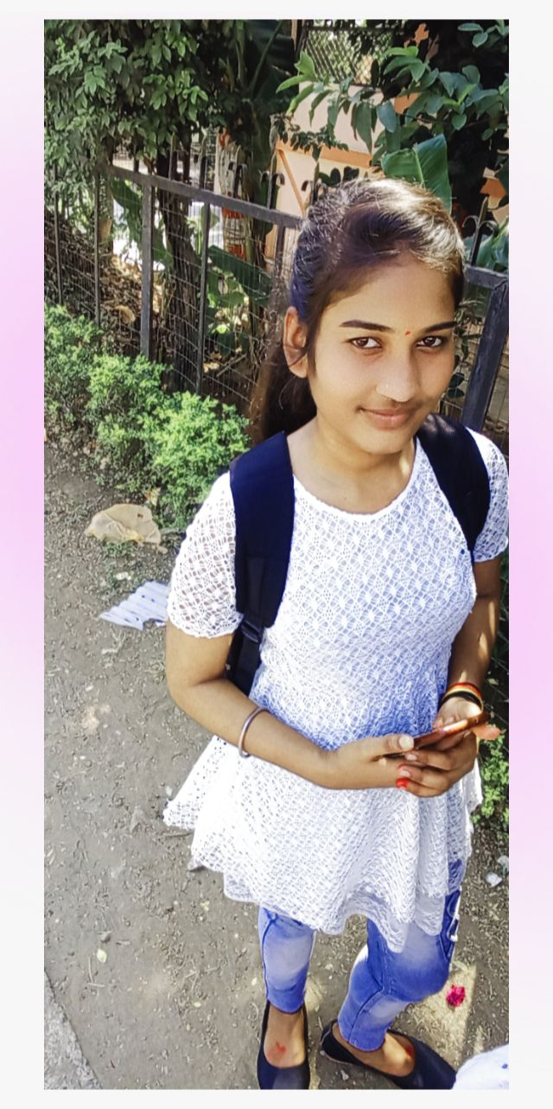 **RESUME**

**Contact**

**Muskan kushwaha**

**Phone**

9098763682

**E mail**

[muskankushwaha@019gmail.com](mailto:muskankushwaha@019gmail.com)

**Adddress**

Rajive Gandhi nagar Iti chungi naka

**Education**

2018

10th pass

m.p. board

2020

12th pass

m.p. board

2023

B.com 3rd year

Rdvv university

**Expertise**

Advance gst (tally, tds )

Data entry operator (m.s word ,m.s excel , m.s powerpoint , internet, email)

**Language**

Hindi

Engliush

CAREER OBJECTIVE

To build career in a growing organization ,where I can get the opportunities to prove my abilities by accepting challenges.

QUALIFICATIOn

* Basic knowledge of computer.
* Ms word , Ms excel, Ms powerpoint, internet ,e mail.
* Advance GST (Tally ,Tds, inventory )

Work experience

* Fresher

Strength

* Positive attitude , good communication skills

Personal profile

* **Father’s name**  Sh. Ramesh kushwaha
* **Date of birth** 05/November/2003
* **Sex** Female
* **Marital status** Unmarried
* **Language known** Hindi, English
* **Nationality** Indian
* **Hobbies** Dancing, Singing,

Declaration

I solemnly declare that all the above information is correct to the best of my knowledge and belief.

**Date:**

**Place : Signature………….**