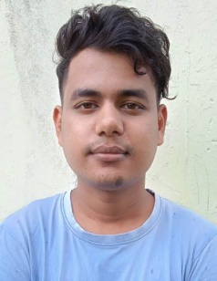 ***Resume***

***NAME = SURAJIT BHOWMICK***

***MOBILE NO. = 9399318856***

***EMAIL ID = surojeetbhowmick98@gmail.com***

***PROFILE DETAILS***

***PROFILE DETAILS***

***FATHERS NAME = MR. MANGAL BHOWMICK***

***DATE OF BITH = 20/04/1998***

***GENDER = MALE***

***MARITAL STUTAS = UNMERRID***

***ADDRESS = VAISHNO MANDIR SITAMANI KORBA CHHATTISGARH***

***PIN CODE = 495677***

***NATIONLITY = INDIA***

***AADHAR NO. = 882077985293***

***EDUCATION DATEILS***

***EDUCATION DATEILS***

***EDUCATION DATEILS***

|  |  |  |  |  |  |
| --- | --- | --- | --- | --- | --- |
| ***CLASS*** | ***SCHOOL/COLLEGE*** | ***BOARD*** | ***PASSING***  ***YEAR*** | ***DIVISION*** | **PARCENTAGE** |
| 10TH | ***GOVT . H. S. SCHOOL KORBA*** | CGBSE | 2017 | ***SECOND*** | ***41.66*** |
| 12TH | ***GOVT . H. S. SCHOOL KORBA*** | CGBSE | 2019 | ***SECOND*** | ***49.6*** |
| B-A FINAL | ***GOVT. E.V.PG COLLEGE KORBA CHHATTISGARH*** | ABVV | 2022 | ***FIRST*** | ***65.94*** |
| ADEO, DDEO | PMKK | N.S.D.C | 2023 | PASS | PASS |

***EXPERINCE***

1. ***10 YEAR EXPERINCE ON SHOE STORE***

***DECLARATION***

***I here by declare that all about imformation in tru to the best of myknowledge and I be ar responsibility for the decaration of this particular.***

***DATE*** **SINGNATURE**

***PLACE***  ***SURAJIt BHOWMICK***