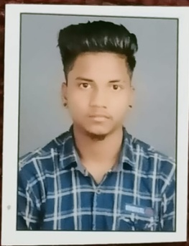**RESUME**

**NAME - SURENDRA KUMAR BARETH**

**MOB NO. - 9691679870**

**EMAIL ID - surendrabareth380@gmail.com**

**PERSONAL DETAIL**

**NAME - SURENDRA KUMAR BARETH**

**FATHER`S NAME - PURUSHOTTAM BARETH**

**DATE OF BIRTH - 08/01/2005**

**NATIONALITY - INDIAN**

**ADDRESS - NURI MASJID ARA MACHINE KORBA (C.G)**

**PIN CODE - 495677**

**AADHAR NO - 559164019396**

**EDUCATION QUALIFICATION**

|  |  |  |  |  |  |
| --- | --- | --- | --- | --- | --- |
| **Sr. No.** | **CLASS** | **SUBJECT** | **BOARD** | **PASSING YEAR** | **PERCENTAGE** |
| 1 | 10th | ----- | CGBSE | 2021 | 88% |
| 2 | 12th | ART | CGBSE | 2023 | ---- |

**DECLARATION**

I here by declare that all above information is true to the best of my knowledge and i bear the responsiblity for the correction of this particular.

Place : Korba (Surendra Bareth)