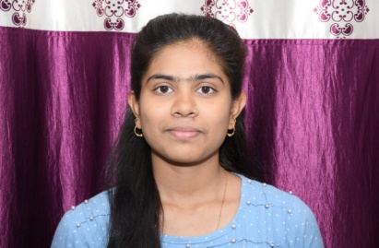**Name : Varsha Patel**

**Mobile No. : +91 7804895804**

**Email ID : varshupatel0910@gmail.com**

Name : Varsha Patel

Father Name : Bhedilal patel

Mother Name : Dhananjay patel

Date of Birth : 09/11/2004

Marital Status : Single

Address : SF-505 cseb colony ,kosabadi korba ,Chhattisghar,495677

Nationality : Indian

**EDUCATION DETAILS**

|  |  |  |  |  |  |
| --- | --- | --- | --- | --- | --- |
| Sr.No. | Class | Subject | Board | Passing Year | Percentage |
| 1 | 10th | -- | CGBSE | 2021 | 97% |
| 2 | 12th | Maths | CGBSE | 2023 | 93% |

**ADDITIONAL QUALIFICATION**

* Basic computer knowledge
* Data entry Operator 3 month experience

**Declaration**

I hereby declare that above information is correct to the best of my knowledge and belief .

0