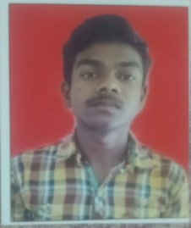**Name : Satyendra Ku. Maravi**

**Mobile No. : +91 9589555412**

**Email ID : satyendramaravi979@gmail.com**

**PERSONAL DETAILS**

Name : Satyendra Maravi

Father Name : Ramkumar Maravi

Mother Name : Rukmani Maravi

Date of Birth : 09/03/2005

Marital Status : Single

Address : ward no. 13 chahuan mauhalla parsabhata balco nagar,korba (C.G.) 495677

Aadhaar No. : 716220460693

**EDUCATION DETAILS**

|  |  |  |  |  |  |
| --- | --- | --- | --- | --- | --- |
| Sr.No. | Class | Subject | Board | Passing Year | Percentage |
| 1 | 10th | -- | CGBSE | 2021 | 95.33% |
| 2 | 12th | Commerce | CGBSE | 2023 | 66.9% |

**ADDITIONAL QUALIFICATION**

* Basic computer knowledge
* Data entry Operator 3 month experience

**DECLARATION**

I hereby declare that above information is correct to the best of my knowledge and belief .

Place : Korba **(Satyendra Maravi)**