**RESUME** 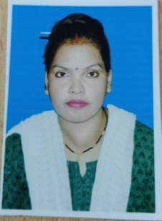

**NAME - PRASANN TIRKEY**

**MOB NO. - 88785176**

**EMAIL ID - prasanntirkey4@gmail.com**

**PERSONAL DETAIL**

**NAME - PRASANN TIRKEY**

**FATHER`S NAME - LATE. DILA TIRKEY**

**DATE OF BIRTH - 16/09/1987**

**NATIONALITY - INDIAN**

**ADDRESS - I.T.I RAMPUR,Korba, (c.g.)**

**PIN CODE - 495677**

**AADHAR NO - 230430896283**

**EDUCATION QUALIFICATION**

|  |  |  |  |  |  |
| --- | --- | --- | --- | --- | --- |
| **Sr. No.** | **CLASS** | **SUBJECT** | **BORAD** | **PASSING YEAR** | **PERCENTAGE** |
| **1** | **10th** | **----** | **CGBSE** | **2005** | **51%** |
| **2** | **12th** | **ART** | **CGBSE** | **2007** | **44%** |
| **3** | **B.A.** | **HINDI LETI.** | **CGBSE** | **2018** | **50%** |
| **4** | **M.A.** | **HINDI LETI.** | **CGBSE** | **2021** | **71%** |

**DECLARATION**

I here by declare that all above information is true to the best of my knowledge and I bear the responsiblity for the correction of this particular.

Place : Korba (PRASANN TIRKEY)