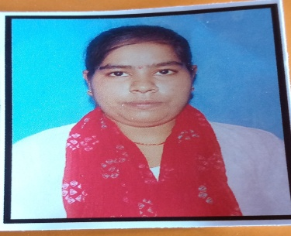 RESUME

Name _ Mahi kashyap

Father’s Name – Dhaniram kashyap

Address –Rajeswa coloni mati kishanpur Kanpur dehat

Village –Mati road

Post – akbarpur

Pin cord- 209101

Contact no-7068387883

Email id – Kashyapchotu7375@gmail. com

D.o.b- 10-07- 2002

Gender – Female

Marital status- Unmarried

Academic qualification-

10th-2018

12th-2020

Graduation- b.sc

Other qualification-

Language known –Hindi/English-

Mahi kashyap