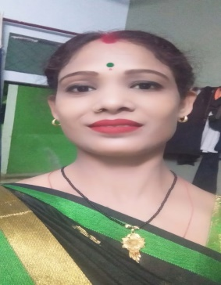 RESUME

ARCHANA

Mob no.:- 7068295010

Email:- [singharchana83225@gmail.com](mailto:singharchana83225@gmail.com)

**CAREER OBJECTIVE :-**

To get required success in the guidance of my seniors and take my career to highest which. I want to do.

**EDUCATIONAL QUALIFICATION:-**

High school pass from UP Board 2003

Intermediate pass from UP Board 2005

**HOBIES:-**

Cooking and Dancing

**JOB PROFILE /EXPERIENCE:-**

Two years Teaching .

Marathon race three year experience.

**PROFESSIONAL QUALIFICATIONS :-**

BPED/ Computer Basic course.

**SPECIAL QUALITIES:-**

Hard working and honesty.

**PERSONAL DETAILS:-**

Father’s Name : Mr Rajkumar

D.O.B. : 02/01/9087

Marital Status : Married

Language known : Hindi /English

Mailing /Address: Mati Road Akbarpur Kanpur Dehat

PIN Code : 209101

Date -13/06/2023

Place- Name- Archana