**RESUME**

**SATTYAM KUMAR MISHRA** 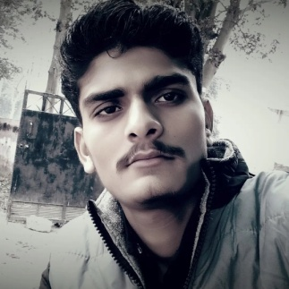

**id Email: Satyammishra521412@gmail.com**

**Mobile no.8009082583**

**Address: Akbarpur Rayramapur Kanpur dehat 209312**

|  |
| --- |
| Objective: |

**Seeking innovative and challenging career in a growing organization which gives**

**Me an opportunity to utilize my skills & knowledge and provides me an opportunity**

**For career growth.**

|  |
| --- |
| Academic profile: |

* **12th J.S inter collage mati in 2022**
* **10th from UP board 2020**

|  |
| --- |
| Technical Experts: |

* **Domestic IT Helpdesk Attendant**

|  |
| --- |
| Skills: |

* **Good communication skill**
* **Quick learner**
* **Ability to work independently**

|  |
| --- |
| Personal Information |

**Father’s Name : Pradip kumar mishra**

**Date of birth : 7march 2006**

**Gender : Male**

**Status : Unmarried**

**National : India**

**Language Known : Hindi**

**Hobbies : Bike ridding**

**Declaration: All the above information is correct to my knowledge and I bear the responsibility of the correctness.**

**Date : 05/06/2023 Satyam mishra**