RESUME

ANIL KUMAR 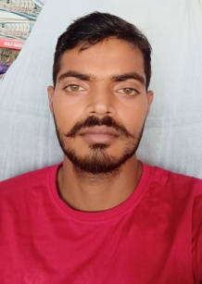

Mob no. 7054895791

E mail. [anilp2107@gmail.com](mailto:anilp2107@gmail.com)

**CAREER OBJCTIVE:-**

To get required success in the guidance of my seniors and take my I want to do.

**EDUCATION QUALIFICATION-:**

High school pass from U.P. Board 2012

Intermediate pass from U.P. Board 2014

HOBBIS:-

reading & spoken English

Painting

**JOB PROFILE/EXPERIENCE :-**

Six month teaching School Experience.

**PROFESSIONAL QUALIFICATION:-**

Computer Basic Course.

**SPECIAL QUALITIES :-**

Communication skills trainer

**PERSONAL DETAILS:-**

Father’s Name Mr.rajendra kumar

D. O. B. 10/08/1997

Marital Status Unmarried

Language Known Hindi , English

Mailing /Residential address Bihari bdi blai akbarpur Kanpur dehat

Code :- 209301

**STRENTH:-**

Positive Attitude

Dedicated with work

Date ANIL KUMAR

Place