**RESUME**

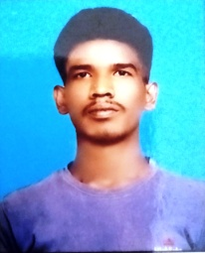

**Sonu kushwaha**

Sharadkush8869@gmail.com

8869935368 , 9569903129

**CAREER OBJECTIVE**

###### Work and Iearn that contribute best for the growth of the organization by continue developing and sharing my skill ability.

|  |  |  |  |  |
| --- | --- | --- | --- | --- |
| **SR NO** | **QUALIFICATION** | **BOARD/UNIVERSITY** | **YEAR OF**  **PASSING** | **PERCENTAGE** |
| 1 | High School | U P Board Allahabad | 2018 | 69.5% |
| 2 | Intermediate | U P Board Allahabad | 2020 | 73.2% |
| 3 | B.sc | C S J M University | 2023 | Apearing |

**STRENTHS**

All time focus on my work.

**SKILL**

Ms office, Excel,Advance excel, tally

**HOBBIES**

Reading books, Listening music, playing cricket

**PERSONAL DETAILS**

* FATHER’s NAME : Santosh kushwaha
* D.O.B : 15-07-2004
* ADDRESS : Ganga ganj kalimathiya panki Kanpur Nagar.

* GENDER : Male
* LANGUAGES KNOWN : Hindi , Bangali, English
* NATIONALITY : Hindu

**DECLARATION:**

I here by declare that all the details furnished here are true to the best of my knowledge

**Sonu kushwaha**