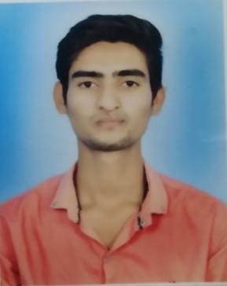**RESUME**

**SAJID ALI**

**Address** : Mahamaya Road Jharhagar Ambikapur (C.G)

**Mob.** : **6261761200**

**E Mail** : sajidali42540@gmail.com

**CAREER OBJECTIVE**

A challenging Career which offers an opportunity to apply my skills Knowledge with continuous learning and growth

**EDUCATION QUALIFICATION**

|  |  |  |  |  |
| --- | --- | --- | --- | --- |
| **Serial No** | **Degree** | **Year** | **Board** | **Percentage** |
| 1 | 10th | 2015 | CG Board | 51.00% |
| 2 | ( ITI ) (MECHANIC,REFIGERATION AND AIR CONDITIONING) | 2018 | STATE BOARD OF EXAMINATION | 66.00% |
| 3 | 12th | 2019 | C.G.BOARD | 51.00% |
| 4 | TELLY ERP9 | 2022 | TELLY SHIKSHA | A++ |
| 5 | GRADUATION | 2022 | SANT GAHIRA GURU VISHWAVIDYALAYA | 75.00% |

**COMPUTER SKILLS**

MS Word,Excel,Power Point,Visual Basic,Tally ERP9 etc.

**PERSONAL DETAILS**

Father’s Name : Md Altaf Ali

Date of Birth : 05.04.2000

Marital Status : Single

Gender : male

Religion : Muslim

Nationality : Indian

Language : Hindi,English,

**DECLLERATION**

I hereby declare that the information provided above is true to the best of my knowledge.

Date…………………..

Place………………….

(Sajid Ali)