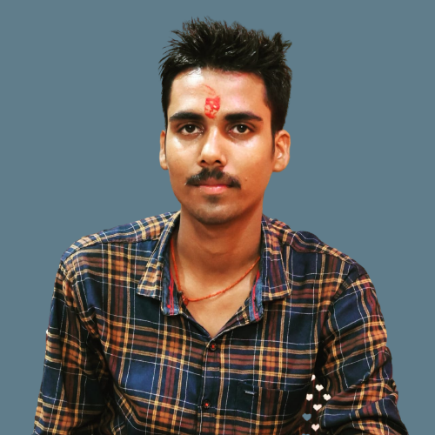ARYAN YADAV

About me: Sincerity and Dedication is my objective to get myself at the grand high of the concern where I will work in, thereby improving my degree of learning so that I will be an assets to my organization.

+91-9696166078 [aryanlg143@gmail.com](mailto:aryanlg143@gmail.com)

206, Narayanpuri, Krishna Nagar, Lucknow

**SOFTWARE**

Excel PowerPoint Word

Photoshop CorelDraw Tally ERP 9.0

# Personal Information

Father’s Name Arvind Yadav

Marital Sataus Unmarried

Date Of Birth 14-11-2002

Gender Male

# Declaration

I here by declare that all información given in this C.V. is correct to best of my knowledge and belief.

# LANGUAGES

Hindi: Native English: Intermediate Nationality: Indian

# EDUCATION

2022- till now

Bachelor of Science

CSJM University

2020-2022

ITI

2019

Intermidiate *State Board* UP, India

2017

High School *State Board* UP, India

Date- Place-

(Aryan Yadav)

# Hobbies

Exploring

Learn New Things

Listening Music