**BIO-DATA**

1. 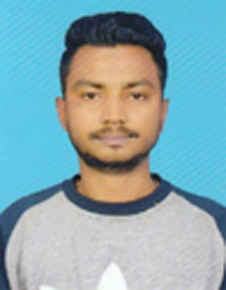**Name :BISWAJIT SAHA**
2. **Father’s Name : Jatan Saha**
3. **Mother’s Name : Minu Saha**
4. **Date of Birth : 17/09/1989**
5. **Nationality : Indian**
6. **Category : General**
7. **Religion : Hinduism**
8. **Sex : Male**

**9. Permanent Address : Town- Gossaigaon Ward No.-3**

**P.O: & P.S. Gossaigaon**

**Dist.: Kokrajhar, Assam.**

**Pin No. 783360.**

**10. Contact No.: 7002721508**

**11. Email ID :** [**biswajitsaha444@gmail.com**](mailto:biswajitsaha444@gmail.com)

**12. Details of Educational Qualification.**

|  |  |  |  |  |
| --- | --- | --- | --- | --- |
| **Examination Pass** | **Board/Council/ University** | **Year of Passing** | **Total Marks Obtained** | **Percentage(%)** |
| **H.S.L.C.** | **SEBA** | **2011** | **180** | **30.33** |
| **H.S.** | **KKHSOU** | **2014** | **128** | **42** |
| **Graduation** | **KKHSOU** | **2020** | **711** | **39.50** |
| **ADCA** | **Sundaram Computer prashikshan kendra** | **2020** | **247** | **49** |
|  |  |  |  |  |

**13. Language Known :Bodo, Assamese, Rajbongshi, Bengali, Hindi, English.**

**14. Experience (if any) :**. **5 Years Experience in Sales/Marketing** **in various sector.**

**Work as a Supervisor in Socio Economic and Caste Census in 2011 under office of the Revenue Cercle at Gossaigaon.**

**All the above specified declarations and also to the fact that the information furnished by me are correct to the best of my knowledge and in case any of the furnished information is found wrong later on my candidature is liable to be cancelled**.

**Place: Gossaigaon**

**Date: 15/07/2023**  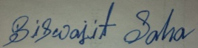

**Signature of the candidates**