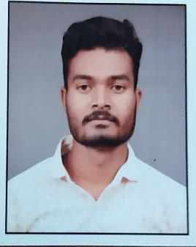 Personal detail

|  |  |  |
| --- | --- | --- |
| **Name:**  **Father name:**  **Mother name:**  **D.O.B. :** | Peshkumar maravi  Mr.samaru lal maravi  Miss.Chanda bai  08/05/1999 |  |
| **Address:** | Manikpur post.Amgwan tah. Niwas dist.mandla |
| **Email:** | Kumarpesh05@gmail.com |
| **Mobile nomber:** | 9865019806 |
| **Martail status:** | married |  |

Educational qualifications



|  |  |  |  |  |
| --- | --- | --- | --- | --- |
| **Sr. No.** | **Degree** | **Year** | **Board** | **Percentage** |
| 1. | 10th | 2015 | Mp Board | 57.16% |
| 2. | 12th | 2017 | Mp Board | 55.8% |
| 3. | ITI | 2022 | Govt.ITI Niwas | 76.3% |
| 4. | B.Com CA. | 2023 | MMYVV | 66.5% |



I hereby declare that information provided above is true to the best of my knowledge.

Date signature

|  |
| --- |
|  |

12/07/2023