**RESUME**

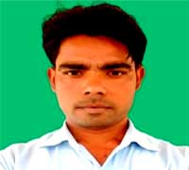**NAME- BRAJESH AHIRWAR**

EMAIL ID: [brajeshahirwar164@gmail.com](mailto:brajeshahirwar164@gmail.com)

MOBILE NO: 9752644792

ADDRESS: Ward 15 Near of Police

Station Badamalehara dist Chhatarpur m.p.

**CAREER OBJECTIVE**

* Obtain a responsible position in an organization with the best capabilities, Skills and knowledge.

**ACADEMIC QUALIFICATION**

* 10th MP BORD BHOPAL , year 2010,54.16%
* 12th MP BORD BHOPAL,year 2013,51.20%
* Computer Diploma DCA,year2014,62.18%
* Bachelor of Arts, MCBU,year 2020,52.62%

**WORK EXPERIENCE**

* Fresher

**PERSONAL DETAILS**

* Father’s Name : Mr. Parsadi Ahirwar
* Date of birth : 25/06/1990
* Gender : Male
* Nationality : Hindu
* Marital status : Maried
* Languages : Hindi/English
* Hobbies : Crickit/ches