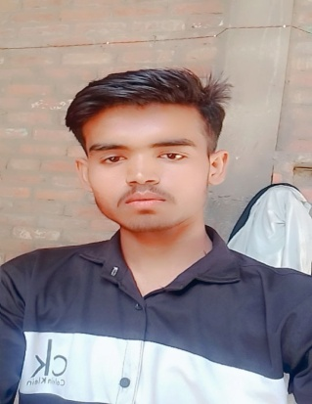**RESUME**

VISHAL

**Address: Gauriyapur Akbarpur Kanpur Dehat** 209101

Mobile : 6392420549

Email: vg050551@gmail. com

**OVERVIEW**

To seek a challenging position in an organization by utilizing my skill , knowledge and learning and to work with full determination. Have good interpersonal communication skills, excellent and adaptability to all kind of environment.

CARRER OBJECTIVE

To add value in the concerned area and to generate perfect business & achieve extra ordinary result for the development of concern and self .

EDUCATION QUALIFICATION:-

10th passed from U.P Board in 2021

12th passed from U.P Board in 2023

Language:-

Hindi, English

PERSONAL DETAILS:-

Name : Vishal

Mother’s Name :Geeta devi

Father’s Name : Vijay Kumar

Date of birth : 03/01/2006

Gender : Male

Marital Status : Unmarried

Nationality : Indian

. I, Vishal do hereby that information given is true to the best of my Knowledge .

Place:-

Date:-

Vishal