RESUME 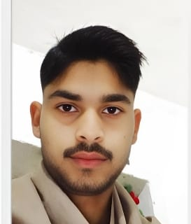

Buddha prakash gautam  
EMAIL ID: [Bpbuddhaprakash@gmail.com](mailto:Bpbuddhaprakash@gmail.com)  
MOBILENO: 7398337512

Objective

Seeking innovation and challenging career in a organization which gives

Me an opportunity to utilize my skill & knowledge and provides me an opportunity for carrier grow.

Academic Profile

. High school in akbarpur inter college akbarpur kanpur dehat   
 Intermediate in akbarpur inter college akbarpur Kanpur Deha

. Study in B.s.c 1nd year

Technical Expertise:.M Excel, Ward and Power Point.

Good communication Skills   
 Quick leaner   
 Ability to work independently  
ITES (Domestic IT helpdesk Attentant)  
Personal information

Father’s name : Mr. Jagdish chandra   
Date of birth : 26/01/2006   
Gender : Male   
Marital Status : Unmarried   
NATIONALITY : Indian  
Language Known : English   
Hobbies : Playing cricket, seeing movies, reading books   
Declaration: All the above information is correct up to my knowledge and the responsibility of the correctness.   
Place: Date:

Buddha prakash