CURRICULUM VITAE
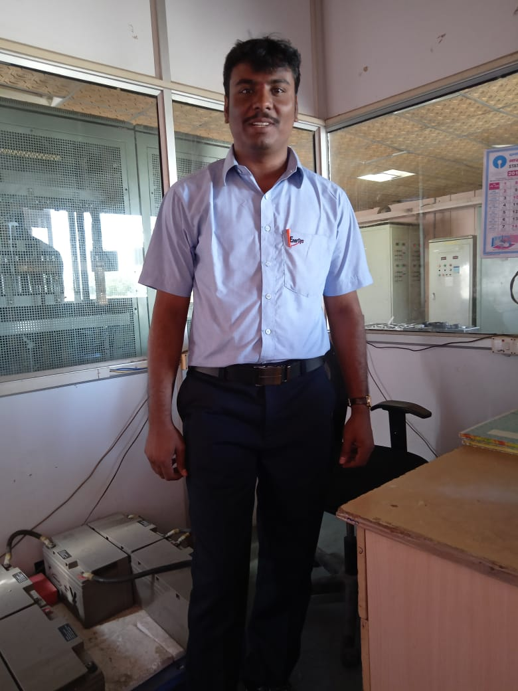
P. JANARDHAN REDDY
S/O :P. Narasimha Reddy, MOBILE: +91-9494936353,7981436115
1-105, Vinayaka Street,
Email: pjr.career@gmail.com
Mundlapudi (V), Tirupati Rural (M),
Tirupathi (D.S), Andrapradesh  517503.
.
Career Objective

To work in the Industrial environment where performance recognized and rewarded and to be a part of growth-oriented organization to deliver the fullest potential and knowledge of mine for the prosperity of the organization.

Education

- M.B.A Degree completed in Distance Education from Madurai Kamaraj University-Madurai, (TN State)
during 2013-2015 (62.42%)
- B. Tech in Electrical & Electronics Engineering, Siddharth Institute of Engineering & Technology,
Puttur - Affiliated to JNTUA during 2005-2009 (62.66 %)
- Board of Secondary Education in M.P.C Group from Vikas Junior College, Tirupati during 2003-2005
(78 %)
- Board of Primary Education in Z.P. High School, Tiruchanoor during 2002-2003 (67.83%)

Technical & Computer skills
- Mini Tab
- Basic Knowledge on SAP
- Microsoft office
- Certified Auto CAD 2010, PC-schematic Elevation
- Basic Knowledge on Electrical & Mechanical Engineering
- Certified Quality control circle
- Six-sigma Green Belt cececertified
EXPERIENCE
- “Worked as Deputy Manager Quality Department for SENATLA INNOVAIVE EV COMPONENTS PVT
LTD since 2nd May 2022 to May 18th 2023 date, RANGA REDDY (District), Cherllapally
Industrial Area, Hyderabad.
Designation :Deputy Manager Quality
Roles and Responsibilities:

- Review of product quality related customer complaint and feedback on Daily basis
- Working closely with various stakeholders (Internal and External)
- Benchmark quality parameter and improve product quality
- Review customer complaints and take solid concurrence actions to achieve 90% customer rating
- Coordinate the Quality activities with mutual departments
- Review in-house, supplier and customer PPM.
- Get PPAP approval from customer and keep in safe Custody
- Prepare inspection standard for incoming, in-process and final inspection
- Overall responsibility for inspection activities at Final Stage
- To maintain safe working condition & good house keeping in the department
- Audit supplier as per annual plan Audit & new supplier with Vendor Team
- Control &Monitor COPQ
- Initiate CAPA against in-house, in-process and SCAP(security content Automation protocol) - customer end quality problems
- Analyze supplier rejection / rework
- Initiate any change/modification required for control plan / FMEA
- Supervise Engineer (Incoming , In-process & Final inspectors)
- Maintain & Update ISO Documentation pertaining to Inspection area
- Daily Review and take appropriate counter action on Parallelism data Analysis
- 8D analysis report preparation for customer complaints
- 7QC tools using for data collection and analysis the same for major issues
- To maintain measuring instruments,accessories,material handling equipment in good working condition
- Field failure data report preparation and conducting meeting with top management to take further corrective action from mutual departments
EXPERIENCE
- “Worked as senior Quality Engineer for Vidyuth control systems Private Limited from Dec 1st 2020 to
March 31st 2022, Medchal District, Medchal Industrial Area, Hyderabad.
Designation :Senior Quality Engineer
Roles and Responsibilities:

- Develop,manage implement,communicate and maintain a quality plan
- Effectively interact with Technical,Development and Production team
- Assisting Engineers to inspect process from initial winding stage to dispatch stage
- Supervise in handling of sample evaluation and production approval
- Monitoring QC/QA performance by gathering relevant production data
- Responsible for each aspect of quality control and product assembly
- Provide enough quality control seminars and coaching for company trainers
- Ensure all quality and production issue by auditing and controlling
- Doing In-line inspection to check Quality
- Follow up pre-final inspection to check Quality
- To keep all necessary documents and quality SOP
- Lead the quality team both QC/QA
- Ultimately ensure the final product quality
- 5S training giving to quality and production team
- Customer complaints attending the different site location to resolve the issue and prepare CAPA report for further corrective action taking inside the plant location without repeating the same issue
- Supplier visiting for ensuring the product and process of receiving products
- Deviation record filling any abnormalities identified at production lines doing brainstorming to do further correction without repeating the same
- 7QC tools applying to collect the data and analysis purpose and making graphical representation for everyone understand
- Weekly once Quality meeting attending with management and discuss fast week quality issues and make action plan to ensure the product quality and process quality in production lines
- Updating the documents as per the ISO standards of both QA/QC
- Process document review every quarterly once to improve the and process quality and employee morale
- Monthly once gathering with total team to discuss production plan
- Ensure FIFO system from stores to Final dispatch stage

EXPERIENCE:

“Worked as Senior Production-Engineer for Enersys India batteries pvt ltd from 29th August 2019 to 18th November 2020 , Narasimharao pallem(Village),Krishna(D.S), Andrapradesh.
Designation: Senior - Production Engineer
- Leading a team of 56 people; managing day-to-day workflow of the Production Team
- Updating smart sheet for plate shop
- Imparting training to employee by implementing 5S and IMS
- Preparing monthly performance report and informing to management
- Directing and maintaining environment and workers electrical safety standards
- Preparing & updating documents / worksheet for preventive & breakdown maintenances as per ISO Standards
- Driving productivity with zero defects, zero rejection
- Managed and controlled the plant scrap to < 2%
- Planned and implemented he strategy to decrease the weekly scrap disposal therefore reducing inventory
- from shop floor
- Ensured LLB target of employee is <19%
- Acted as CII Zonal to enhance day-to-day operational activities
- Recognized for achieving the production targets by 100%.
- Efficiently improved the plant capability by implementing projects through Six-sigma Lean training
- Took challenge of working section initiatives to streamline / enhance production processes
EXPERIENCE:

“Worked as Senior Production-Engineer for Amara Raja Batteries Limited from 11th October 2013 to
29th August 2019 , Karakambadi, Chittoor (D.S), Andrapradesh.
Designation: Senior - Production Engineer
Roles and Responsibilities:
- Ensuring all input materials availability for smooth production
- Target reaching as per the production schedule

- Updating the ISO standard records in every month
- Produce best quality product to reach customer demand
- Undertake continuous training and development for better quality improvement of producing product
- Management training program providing quality system adhered (TPM, TQM, 5S, AAR, ISO) through training
- Poka -Yoke (Error- proofing) where possible to prevent Errors at Work place
- Hourly once monitoring the machine set up approvals to give awareness to operators to maintain process parameters with in specifications
- Actions deriving/execution for previous day abnormalities (Production/Quality/Scrap)
- Highly responsive to assure quality control at all stages of production
- Contribute to continuous improvement activities to produce world class products for best satisfaction of customers
- Actions deriving/Execution Un-safe conditions & Un-safe acts at work place.
- Perform root cause analysis and resolve problems (4M- Man, Machine, Material & Method)
- Identification of improvements scope & generation ideas for successfully execute the selected major problems
- Plan and organize with maintenance & respond to breakdowns
- Preventive maintenance leading to keep machine good condition to reach production as per the schedule with good product quality
- Work instruction preparing & display to production and training to team to produce better Quality product to reach customer Expectations
- Project Title: More break downs in Stacker aligning brushing machine
- Project Title: More wet plate rework in pasting lines
- Project Title: Un-safe condition & Un-safe action while loading the moving molds for grid casting machines
- Project Title: Lead in air is high at Oxide plants
Tools Used in my Job activity: 1. DMAIC
7QC tools used applied for the projects is 1. check sheet 2. cause and Effective Diagram 3. Flow chart 4. Pareto analysis 5. Control charts 6. Scatter Diagram 7. Histogram
Methods applied for projects Execution is 1. Brainstorming 2. Why-Why analysis 3. Poke-Yoke 4.4W-1H 5.5S 6. Kaizen 7. Single Minute Exchange of Dies 8. Takt time 9.TPM 10.TQM Etc.
- Advantage Project 1: Production efficiency is increased 0.5MnAh/Month and 6MnAh for Annum.
- Advantage Project 2: Rework plate scrap reduced & plate quality as well as operator safety also improved
- Advantage Project 3: Operator safety improved
- Advantage Project 4: Lead in air reduction in oxide plant

“Worked in Veolia Water India Pvt Ltd, Ilkal, Bagalkot (D.S), Karnataka state During the Period
(January 17th 2013 to September 2013).
PROJECT: Construction works and services for operation management of 24x7 water supply for ILKAL City,
Bagalkot (District), Karnataka State.
Position: Jr. Electrical Engineer
Roles and Responsibilities

- Supplying required things to labors during damaging water pipelines

- Prepared the work sheets for preventive & breakdown maintenances
- Maintenance of D.G sets
- Surveying by using Auto level and training on laying pipeline works
- Supervising skilled and unskilled labors for earth works
- Showing the alignment for Excavation and laying HDPE pipes.
- Updating daily work status and reporting to site Manager.
“Worked in Apache Footwear India Pvt Ltd, Mambattu (V),Thada (M) Nellore (D.S) from 19th April 2010
to 10th January 2013.
Designation: Assistant-Engineer

Roles & Responsibilities

- General maintenance and services of 11kv substation & Maintenance of D.G sets
- Handling skilled and unskilled operators.
- Maintain and supervise Electrical safety standards of environment and the workers.
- Prepared the work sheets for preventive & breakdown maintenance.
- Updating preventive & current breakdowns in maintenance record sheets.
- Updating the documents as per the ISO standards every month.
- Improve multi skill operators to Improve the knowledge and good communication
Skills and Attributes:
- Understanding manufacturing processes
- Strong problem-solving skills
- Planning and prioritizing activities
- Ability to present data effectively
- Team working skills
PERSONAL DETAILS

FATHER NAME : P. NARASIMHA REDDY
DATE OF BIRTH : 15 JUN 1987
LANGUAGES KNOWN : English, Telugu, Tamil , Kannada & Hindi
HOBBIES : Watching cricket, Listening to music, Reading books
DECLARATION:

I hereby declare that information furnished above is genuine to the best of my knowledge and belief.

PLACE:

DATE: [P. JANARDHAN REDDY]

