**RESUME**

**KAMAL ROY.**

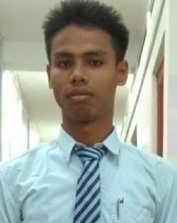**Mobile No:-**8751835478, 9365519461.

Email: - kamalroy2016assam@gmail.com

Career Obejective:-To Be a Successful professional in a Globally Respected Company and to achieve the objectives of the company whit Honesty and Fairness and to Continuously Upgrade My Knowledge and Skills.

**Academic Qualification:**

|  |  |  |  |
| --- | --- | --- | --- |
| **Examination** | **Board** | **Year of Passing** | **Percentage** |
| 12th | AHSEC | 2015 | 39% |
| 10th | SEBA | 2013 | 50.33% |

**Key Skills**

Operating System:- Window 07.

Application :- MS-Office 2007,Typing master pro, Inter Net,

**Vocational Training**

Successfully completed 8months Basic Electrician Vocational training from the Govt. project DDU-GKY, Bongaigaon under “ICA” Company.

**Achievements**

Achieved 2nd position in HSLC board Exam.

Achieved 3rd position in HS Exam.

**Personal Details**

Father Name: - Subal Roy.

Mother Name: - Puspeswari Roy.

Date of Birth: - 1 Jan 1997.

Address: - Vill. - Bongaon, PO. - Noyagaon, PS. - Jogighopa, Dist- Bongaigaon, (Assam). Pin. - 783384.

Blood group: - O+

Cast: - OBC.

Nationality: - Indian.

Community: - Koch-Rajbangsi.

Religion: - Hinduism.

Hobby: - Play Football.

**Languages known:-**

|  |  |  |  |  |  |
| --- | --- | --- | --- | --- | --- |
| **Languages** | **Red** | | **Write** | | **Speak** |
| English | Yes | | Yes | | Yes |
| Hindi | Yes | | Yes | | Yes |
| Assamese | | Yes | Yes | Yes | |

**Declaration:** I hereby declare that all the above mentional information given by me is true and correct to the best of my knowledge and belief.

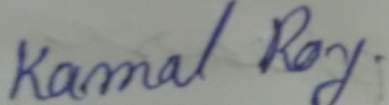

**Place: - (Signature)**

**Date:-**