**RESUME**

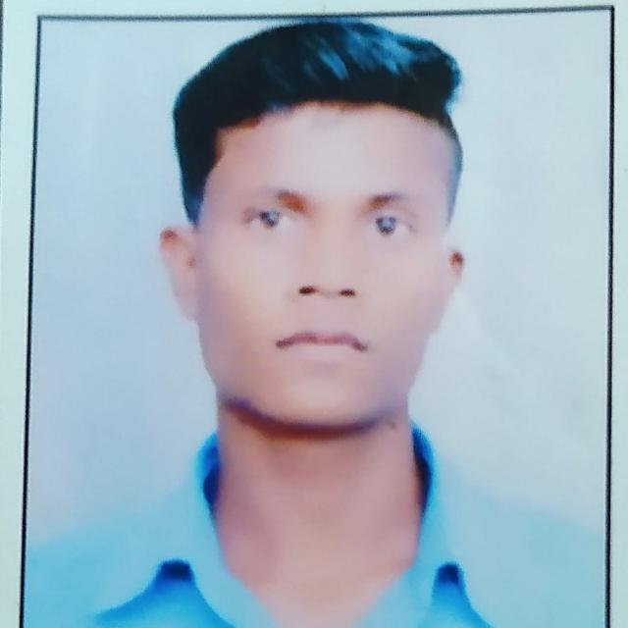

NAME :- ANIL KUMAR

FATHER’S NAME :- BUDH SINGH

MOTHER’S NAME :- BHADDO BAI

PERSONAL DETAILS :-

DATE OF BIRTH :- 01/11/1999

ADDRESS :- VILLAGE DALKA GOPANGI POST RAMHEPUR

BLACK GHUGHARI DIST. MANDLA (M.P.)

QUALIFICATION : -

|  |  |  |  |  |
| --- | --- | --- | --- | --- |
| S.NO. | DEGREE | PASSING YEAR | BOARD | PERCENTAGE |
| 01 | 10 TH | 2015 | M.P. BOARD | 55.18 |
| 02 | 12TH | 2017 | M.P. BOARD | 58.06 |

EXPERIENCE :-

I HAVE A TWO MONTH COMPUTER TRAINING

DECLARE :-

I Hereby declare that information provided above is true to the best my knowledge .

Place :-

Date :- Signature