**RESUME**

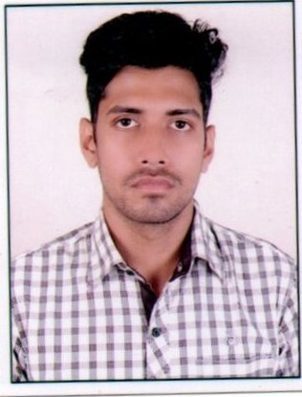

**ABHIRAM PRADHAN**

**CONTACAT INFORMATION :-**

S/O – HARMOHAN PRADHAN

AT- JHARAPADA

PO-BUDHESWARI COLONY

DIST- KHURDA, PIN -751006

MOB - 9583043137

EMAIL- abhirampradhan7@gmail.com

**EDUCATIONAL QUALIFICATION :-**

|  |  |  |  |  |
| --- | --- | --- | --- | --- |
| **SR. NO** | **DEGREE** | **YEAR PASSOUT** | **BOARD** | **PERCENTAGE** |
| **1** | 10TH | 2013 | BSE ODISHA | 75.83 |
| **2** | +2 | 2015 | CHSE ODISHA | 62 |
| **3** | Graduation | 2018 | UTKAL UNIVERSITY | 50 |

**OTHER QUALIFICATION :-**

**\*PGDCA IN COMPUTER FROM SR COMBINE (2018-2019)**

**\*TELECOM IN STORE PROMOTER FROM PRADHAN MANTRI KOUSAL VIKAS YOJNA(PMKVY)**

**WORK EXPERIENCE :-**

WORKING AS A BANKER IN ICICI BANK LTD

**STRENGTH/SKILLS :-**

**\***PANTUALITY

*HONESTY

*HARDWORKING LEADERSHIP

* GOOD COMMUNICATION POSSES GOOD CONVINCING ATTITUDE.

**PERSONAL DETAILS :-**

FATHER’S NAME : HARMOHAN PRADHAN

MOTHER’S NAME : ARATI PRADHAN

DATE OF BIRTH : 14.07.1998

NATIONALITY : INDIAN

RELIGION : HINDU

GENDER : MALE

LANGUAGE KNOWN : ODIA, HINDI & ENGILISH

HIGHT : 6 FEET

COLOUR : FAIR

MARITIAL STATUS : UNMARRIED

STATE : ODISHA

**DECLARATION: -**

**I do hereby declare that the above-mentioned curriculum-vitae information is true & fair to the best of my knowledge.**

**DATE**

**PLACE (ABHIRAM PRADHAN)**