**Resume**

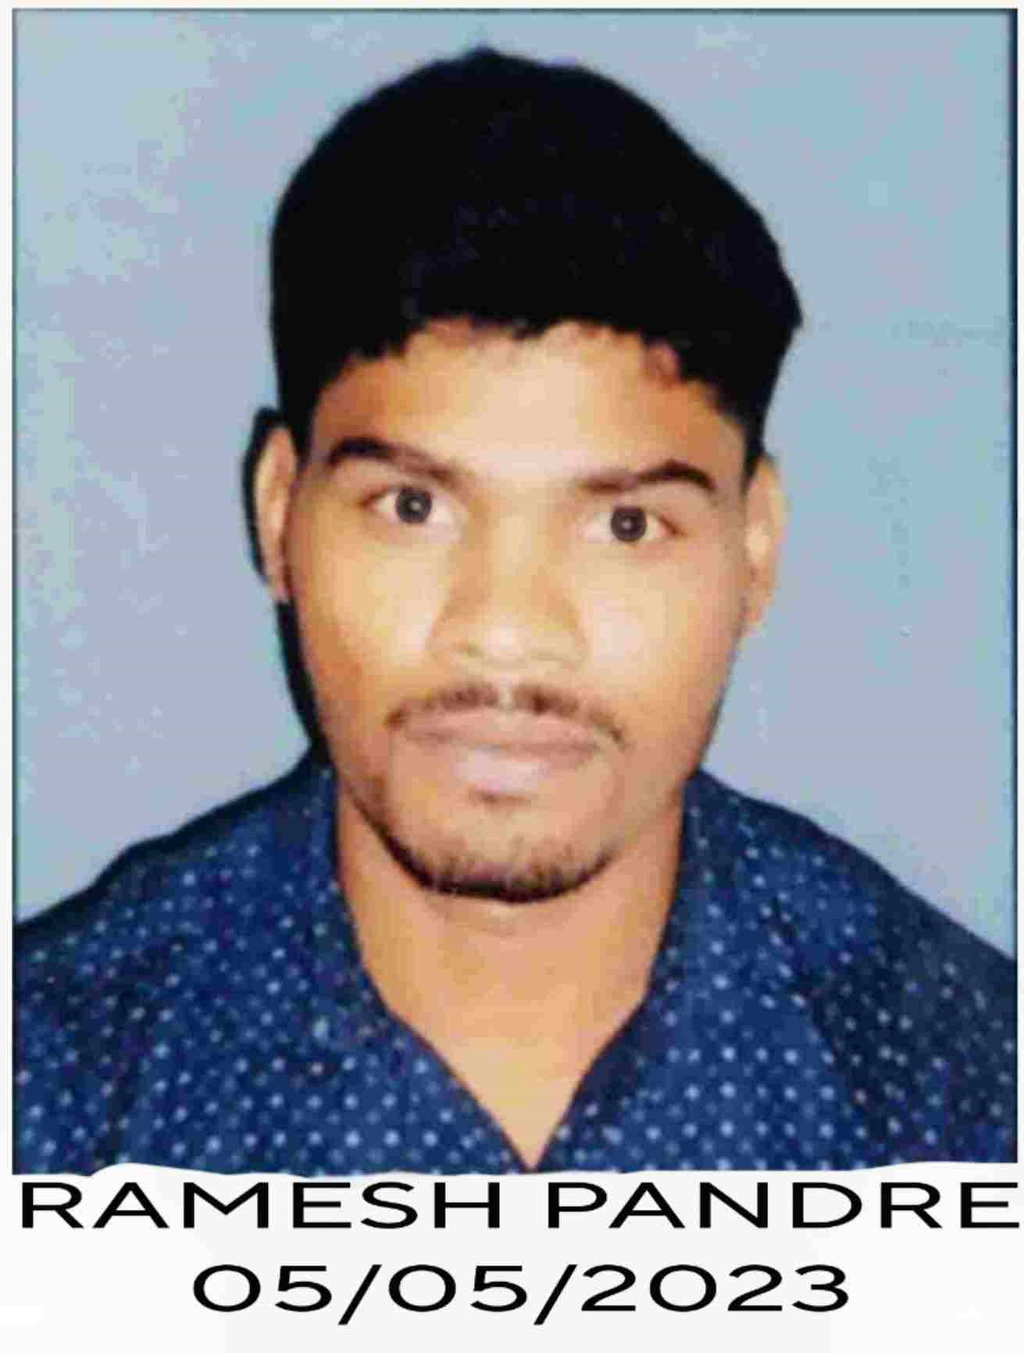

**RAMESH PANDRE**

**Address:**

Near Guru Govind Singh Park, Street Behind,

Roshan Hospital, Govindapura, Bhopal,

Madhya Pradesh

**Contact No.:** 8966846455

**Email id:** [rameshpandre89@gmail.com](mailto:rameshpandre89@gmail.com)

***Career Objective/ -------------------------------------------------------------------------------------------------------------------------------***

* Self-motivated and hardworking fresher seeking for an opportunity to work in a challengingenvironment to prove my skills and utilize my knowledge & intelligence in the growth of the organization.

***Academic Qualification***

|  |  |  |  |  |
| --- | --- | --- | --- | --- |
| **Exam Name** | **Board / University** | **Passing year** | **Percentage of Marks** | **Division** |
| 10th | Board Of Secondary Education Bhopal, M.P. | 2017 | 58% | Second |
| 12th | Board Of Secondary Education Bhopal, M.P. | 2019 | 63% | First |
| B.Sc(Bio.) | Raja Shankar Shah University Chhindwara, M.P. | 2022 | 62% | First |
| D. Pharmacy | RGPV University Bhopal, Madhya Pradesh | Running | Running | Running |

***Professional Qualification***

|  |  |  |  |  |
| --- | --- | --- | --- | --- |
| **Exam Name** | **Board / University** | **Passing year** | **Percentage of Marks** | **Division** |
| General Nursing Assistant (GDA) | Narmada Nursing Training Centre Chhindwara | 2022 | 88% | First |
| Diploma in Nursing and Patient Care[Online] | Alison Online Education Hub | 2023 | 80% | First |
| Diploma in Computer Application [Online](DCA) | STP Computer Education, New  Delhi | 2023 | 84% | First |

***Extra Qualification***

* Soft Skills For Healthcare, Time Management Skill, Global Service Desk Program, Basic Computer Course, Python, Cyber Security Awareness, Basic Hotel Management Course(Online )

***Work Experience***

* 2 Year Work experience as a Nursing Staff Aarogya Hospital Chhindwara

***Personal Information***

Date of Birth : 27-05-2001

Father's Name : Mr. Manjulal Pandre

Mother's Name : Mrs. Bakhatiya Bai

Nationality : Indian

Gender : Male

Marital Status : Unmarried

Language : Hindi, English, Sanskrit

Hobbies : Physical Activity, Internet Browse,Games and Listen Music

***Declaration:***

I hereby declare that all the statement made in this resume are true, complete and correct to the Knowledge

***Date: (RAMESH PANDRE)***

***Place:***