RESUME

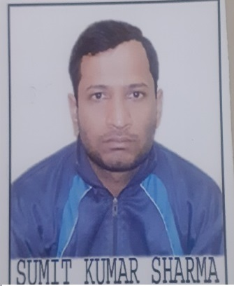 SUMIT KUMAR SHARMA

Address:- Plot no.:-14,

Water Stone Colony,

Tilhari,Jabalpur(M.P)

Phone: +919424542487

E-mail: sumit9981sharma@gmail.com

Career Objective: To do my best in the job assign to me.

Education Qualification: Completed B.E (CS) from Shri ram institute of Science and technology Jabalpur (M.P) with 6.87 CGPA.

|  |  |  |  |  |
| --- | --- | --- | --- | --- |
| Qualification | Year | Institution | Board/University | Marks |
| B.E | 2011-15 | S.R.I.S.T Jabalpur | R.G.P.V. | 6.87 CGPA |
| AISSCE  (12TH ) | 2011 | KendriyaVidyalaya | CBSE | 63% |
| AISSE  (10TH) | 2009 | KendriyaVidyalaya | CBSE | 86% |

Technical Skills:

* Programming Languages:- C,C++,Core Java,Python, Web development
* Computer Proficiency Certification Test : Qualified

Extra-Curricular Activities:

I have participated in social services:-

1. I had collected money for cancer and aids society.
2. I had participated in plantation work.
3. I had also participated in social work held at Paat Baba Temple.

Awards and Achievements:

Participated in DAKSHTA-2014 held at TAKSHSHILA INSTITUTE OF Engineering AND TECHNOLOGY and secure rank under top 15.

PROJECTS UNDERTAKEN: 2

Minor Project : Hostel Management System

Team Size : 04

Description : My project is based on Hostel Management and it was user friendly

That any User can easily find the facilities of room and correspond-

-ing various other services, such as mess facilities and pay the rent

And mess as well.

Major Project : Online Book Shop

Team Size : 01

Description : My Project is based on Online Book Shop and it was made to do

Easily online book shopping.

Personal Details:

* Father’s Name : Shri Ajay Kumar Sharma
* D.O.B : 01 May 1993
* Nationality :Indian
* Sex : Male
* Language Known : Hindi and English.

Hobbies:

* Listening Songs, Cycling.

Strengths:

* Patience, Quick Learner, Punctuality and disciplined.

DECLARATION

I, hereby declare that the information furnished above is true to the best of my knowledge.

Place: Jabalpur (MP)

Date :

(SUMIT KUMAR SHARMA)