## RESUME

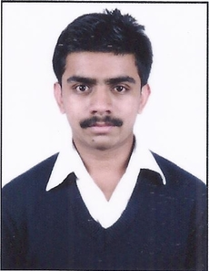

**RISHI BHATTACHARYYA**

|  |  |  |
| --- | --- | --- |
| Profile Organized and dependable candidate successful at managing multiple priorities with a positive attitude. Willingness to take an added responsibilities to meet team goals. Contact PHONE:  9474599954 / 8762053954  EMAIL:  [parthas_bhattacharyya@rediffmail.com](mailto:parthas_bhattacharyya@redimmmail.com)  ADDRESS:  Kolkata 700075, West Bengal, India. |  | EDUCATIONKendriya Vidyalaya Mysore, Karnataka. **(Central Board of Secondary Education)**  2015-2016  Secondary Education. Deeksha Mother Teresa, Mysore, Karnataka. 2106-2018  Higher Secondary Education.  **St Philomena College, Mysore, Karnataka.**  2018 – Current  Bachelor of Science**.**  **Perusing Diploma in Medical Lab Technician Course from IMA**  **Recognised Institute.** WORK EXPERIENCE Fresher. SKILLS  1. Basic knowledge of computer. 2. In-depth knowledge in MS Word and Excell. 3. Typing speed of 30 w.p.m. 4. Active Listening. 5. Decision – Making. 6. Leadership. 7. Written Communication. 8. Interpersonal Communication. 9. Analytical And Critical thinking. 10. Cultural Awareness. 11. Critical Thinking. 12. Self – Motivated. |