**RESUME**

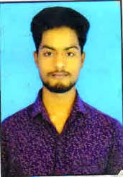

**RISHAV KUMAR**

+91 74883 18078

Email id. [rishavkumar17789@gmail.com](mailto:rishavkumar17789@gmail.com)

**OBJECTIVE**

A highly organized and hard-working individual looking for a responsible position to gain practical experience.

**EDUCATIONAL QUALIFICATION**

* Pursuing B.A 3st year from Markham College of Commerce.
* Passed out 12th from JAC in 2019.
* Passed out 10th from CBSE in 2017.

**TECHNICAL SKILLS**

* Basic knowledge of computer.

**WORK EXPERIENCE**

* I Was Supervisor of Chilli Vanilla Restaurant .
* Presently Working as a Cashier in Shree Jee Fashion.

**STRENGTH & HOBBIES**

* Hard & Smart working
* Honest & Punctual
* Good Communication Skill

**PERSONAL DETAILS**

Father’s Name : Binod kr. Saw

DOB : 25TH June 2001

Address : Baba Path Hurhuru, Hazaribag (Jharkhand) 825301

Marital Status : Unmarried

Nationality : Indian

Language : Hindi & English

**DECLARATION**

I hereby declare that the above statements furnished by me is true to the best of my knowledge and belief.

Date……………………… Place………………………………