**NAME**: **DEVANSH SHARMA** 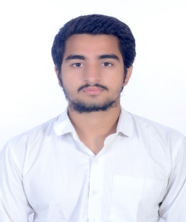

**EMAIL ID**: [DEVANSHSHARMA83499@GMAIL.COM](mailto:DEVANSHSHARMA83499@GMAIL.COM)

**MOBILE NO**: **8349927228**

**OBJECTIVE :**

* TO WORK FOR AN ORGANISATION WITH SINCERITY AND DEDICATION SO AS TO ENHANCE MY KNOWLEDGE IN CONJUCTION WITH ORGANISATIONAL REQUIREMENT AND SEEK A SUITABLE POSITION COMPETING TO MY EXPERIENCE SKILLS AND ABILITY.

**ACADEMIC PROFILE:**

|  |  |  |  |  |  |  |  |  |  |  |  |  |  |  |  |  |  |  |  |  |
| --- | --- | --- | --- | --- | --- | --- | --- | --- | --- | --- | --- | --- | --- | --- | --- | --- | --- | --- | --- | --- |
| |  |  |  |  |  | | --- | --- | --- | --- | --- | | **S. NO** | **QUALIFICATION** | **UNIVERSITY/ BOARD** | **YEAR** | **PERCENTAGE** | | **1** | BBA | DR.C V RAMAN UNIVERSITY KHANDWA | 2024 | 68.87 | | **2** | 12TH | CBSE | 2021 | 76.2 | | **3** | 10TH | CBSE | 2019 | 51.4 | |

**VOLUNTERSHIP :**

* SURVEYED AS A VOLUNTER IN THE NATIONAL LEVEL UNIVERSITY PROGRAM AISECT GROUP . **(VISHWARANG)**
* SURVEY AS A VOLUNTER IN ROBIN HOOD ARMY ( RHA KHANDWA )
* VOLUNTEER AS A REFRESHMENT COMMITTEE MEMBER IN THE CONVOCATION PROGRAM.

**ACHIEVEMENT :**

* CBSE INTER SCHOOL ( NATIONAL FOOTBALL CHAMPIONSHIP )
* DISTRICT FOOTBALL TOURNAMENT ( 3RD PLACE )
* FOOTBALL MERIT CERTIFICATE (FIRST PLACE )
* STATE LEVEL SWIMMING COMPETITION ( INDORE )
* DISTRICT LEVEL SWIMMING COMPETITION ( 2 GOLD MEDAL

2 SILVER MEDAL )

* DISTRICT LEVEL MALLAKHAMBA
* ATTENDED PARADE AS A NCC CADET ( 15TH AUGUST AND 26TH JANUARY )
* SPORTS MEET 2ND PLACE ( 400 METER RELAY RACE )

**EXTRA CO-CURRICULAR :**

* PARTICIPATED IN DEBATE COMPETITION IN UNIVERSITY .
* GOT THE OPPORTUNITY TO MAKE AND PRESENT THE PRESENTATION IN UNIVERSITY WITH PROFESSER **.**

**HOBBIES :**

* READING BOOKS.
* LISTENING MUSIC .
* CUROSITY TO EXPLORE NEW THINGS.

**STRENGTHS:**

* COMMUNICATION SKILLS.
* LEADERSHIP.
* CRITICAL THINKING.
* TEAM WORK .

**PERSONAL INFORMATION :**

**NAME FATHER: KAMLESH SHARMA.**

**DOB: 30/12/2003**

**NATIONALITY : INDIAN**.

**ADDRESS:** WARD NO 25 GULLY NO 04 BHAVSAR LAAJ K SAMNE BHAWANI MATA WARD KHANDWA.

**DECLARATION :**

I HEREBY DECLARE THAT ALL THE INFORMATION GIVEN HERE IS CORRECT AND TRUE TO BEST OF MY KNOWLEDGE .

**DATE: 10-10-2023** 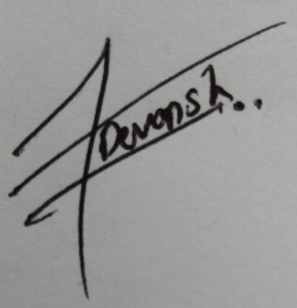

**PLACE: KHANDWA DEVANSH SHARMA**