**RESUME** 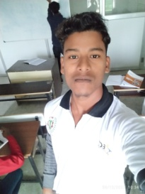

**NAME:** SUNNY RAJAK

**ADDRESS**: MEENA BAZAR MADHUPUR DEOGHAR(JHARKHND)

**Email:** sunnykumar038@gmail.com

**MOB NO:**6201899745

**CAREER OBJECTIVE**

TO take up a challenging career and grows with honesty , loyalty, good relationship and best performance and translate my experience , knowledge , skills and abilities into value for an organization,

**ACADEMIC QUALIFICATION**

|  |  |  |  |  |
| --- | --- | --- | --- | --- |
| 10th | JAC BOARD | 2016 | 272 | 54.4% |
| 12th | JAC BOARD | 2018 | 239 | 47.8% |

**Computer skills**

**Ms word, excel , power point, ms access,**

**& tally with GST**

**STRENGTH FACTOR**

**Good strength of working with team ,strong ability**

**To work creative & determination**

**PERSONAL PROFILE**

Father name : DILIP RAJAK

Date of birth : 15/10/2001

Marital status : Unmarried

Gender : Male

Religion : Hindu

Nationality : Indian

**DECLLERATION**

I do here by declare that the statements made in this document are true the best my knowledge and believe

**DATE:**

**PLACE:**

**(SUNNY RAJAK)**