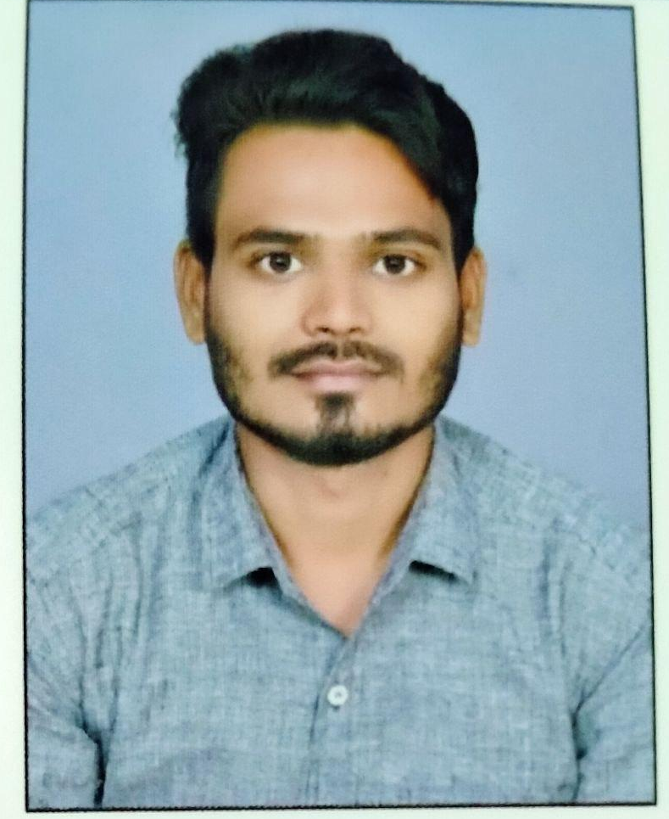
MANHARAN VAISHNAW

7987494918/9630362630  mannuvaishnaw4393@gmail.com

- Career Objective:
To become a sound and proficient Management working as a part of an esteemed organization where my technical knowledge & skills can suitably be utilized & improved with the best possible result.
- Academic Qualification:
Courses | Name of college/ Institution | Board/  University | Year of Passing | Passing Percentage
10th | Govt. High School  Bhilai Bazar | C.G.board Raipur | 2009 | 54 %
12th | Govt. Higher Sec. School Mongra | C.G.board Raipur | 2012 | 52%
B.A. | Govt. M.D.P. College  Katghora | Bilaspur University | 2016 | 43.4%
P.G.D.C.A. | Dr. C.V.Raman University | C.V.R.U. | 2018 | 70.1%

- Experience:
- State Bank of Bank India Data Entry Oprator
Jan 2018 – Apr-2023

- Computer Knowledge:
- Internet
- Operating System (Windows-XP, Windows7, Windows 10)
- MS-Office

- Certification
- C++ Language
- Typing English

- STRENGTHS:
- Keen to learn new things
- Confidence & Consistent
- Ability to work hard
- Team work

- Personal Details:
- Name :Manharan Das Vaishnaw
- DOB : 04th March 1993
- Father’s Name : : Mr. Shyam Sundar Vaishnaw
- Mother’s Name :Mrs. Radha Bai Vaishnaw
- Language Known :English, Hindi,
- Hobbies : Playing Games, Reading Books, Cricket.
- Permanent Address : 4No. Dafai, Banki Mongra, Tah- Katghora
Dist- Korba C.G. pin- 495447

- Declaration:
I affirm that information given in this application is true to the best of my knowledge. I also fully understand that if at any stage it is discovered that any attempt has been made by me to willfully conceal the fact, my candidature may summarily be rejected.

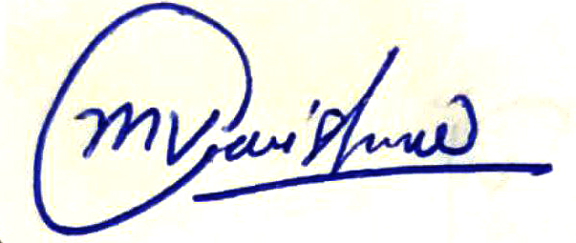
Date : / /
Place : Korba
(MANHARAN VAISHNAW)

