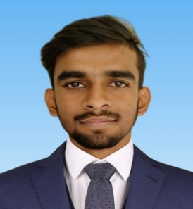NAME: -ATANU MANDAL

BACHELOR OF ENGG.BRANCH: -DIPLOMA IN ELECTRICAL ENGINEERING

YOP: - 2023

MOB: - + 91-7865917093

E-MAIL: - [atanumandal2004@gmail.com](mailto:atanumandal2004@gmail.com)

OBJECTIVE: -To important my skill and knowledge towards the development of organization and to reach my full potential.

**EDUCATIONAL QUALIFICATION**

|  |  |  |  |  |  |
| --- | --- | --- | --- | --- | --- |
| **Course** | **Stream** | **Institute** | **Board / University** | **Date of Passing** | **Percentage** |
| MP | All subject | BHAGABANPUR HIGH SCHOOL(H.S) | W.B.B.S.E | 2020 | 59.57% |
| Diploma | Electrical Engineering | BUNDWAN POLYTECHNIC | WBSCTVE & SD | 2023 | 70.5% |

**Skill Set (OPTIONAL FOR EXTC/ETRX STUDENTS)**

* Operating Systems : Windows
* SKILLS : DCA,MS-Office, Hardwar and Networking ,Advance Excel.

**Academic Projects AND PAPERS PRESENTED**

|  |  |  |  |
| --- | --- | --- | --- |
| ACADEMIC  PROJECTS | *Include details of all academic projects*  Title:1. FABRICATION OF ELECTRICAL CIRCUTI USING SOLAR PANEL  2. RECTIFIER BASED BATTERY CHARGER | | |
|  |  |  |  |

**INTERNSHIP AND WORK EXPREIENCE (IF ANY)**

*Details about internship on Industrial automation (PLC) and implementing the project titled STAR-DELTA-STARTER-BY-PLC

**Co-Curricular and Extra Curricular Activities**

*Co-Curricular Activities: Technical Competitions, Certifications, etc.*

*Extra-Curricular Activities: Cultural, Sports, etc.*

**Personal Details**

* Date of Birth : 12/04/2004
* Languages Known : BENGALI, HINDI
* Nationality : INDIAN
* Religion : HINDU
* Marital Status : SINGAL
* Address : BAGJURI, GHOLGORIA, BANKURA, WEST BENGAL

**Declaration**

I hereby declare that the above – mentioned information is correct and true to the best of my knowledge. My own responsibility for the correctness of the above-mentioned particulars.

Place :

Date : **Full Name\***