**Resume**

Name:- Abhishek ahirwar 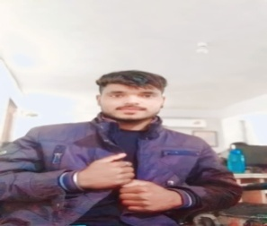

Mobile :-7879106947

E-mail id:- abhisekasuryavnsi026@gmail. com

Ad:- Bhariyakhedi,Piprai,Ashok Nagar (mp.)

**Qualification:-**

|  |  |  |  |
| --- | --- | --- | --- |
| Class | Bord of university | year | % |
| 10th | MP.BORD | 2020 | 40% |
| 12th | MP.BORD | 2022 | 48.8% |
| B.A | Jiwaji university | running | running |
| DDEO | computer | running | running |

**persnol detail**Name- abhishek ahirwar

father’s name ms.shripal ahirwar

Mother’s Name full bai Ahirwar

Gender – Male

Language- hindi

Date of Birth:- 04/02/2005

Date:- 04/01/2024

Place:-Ashok nagar (mp.)

Abhishek ahirwar